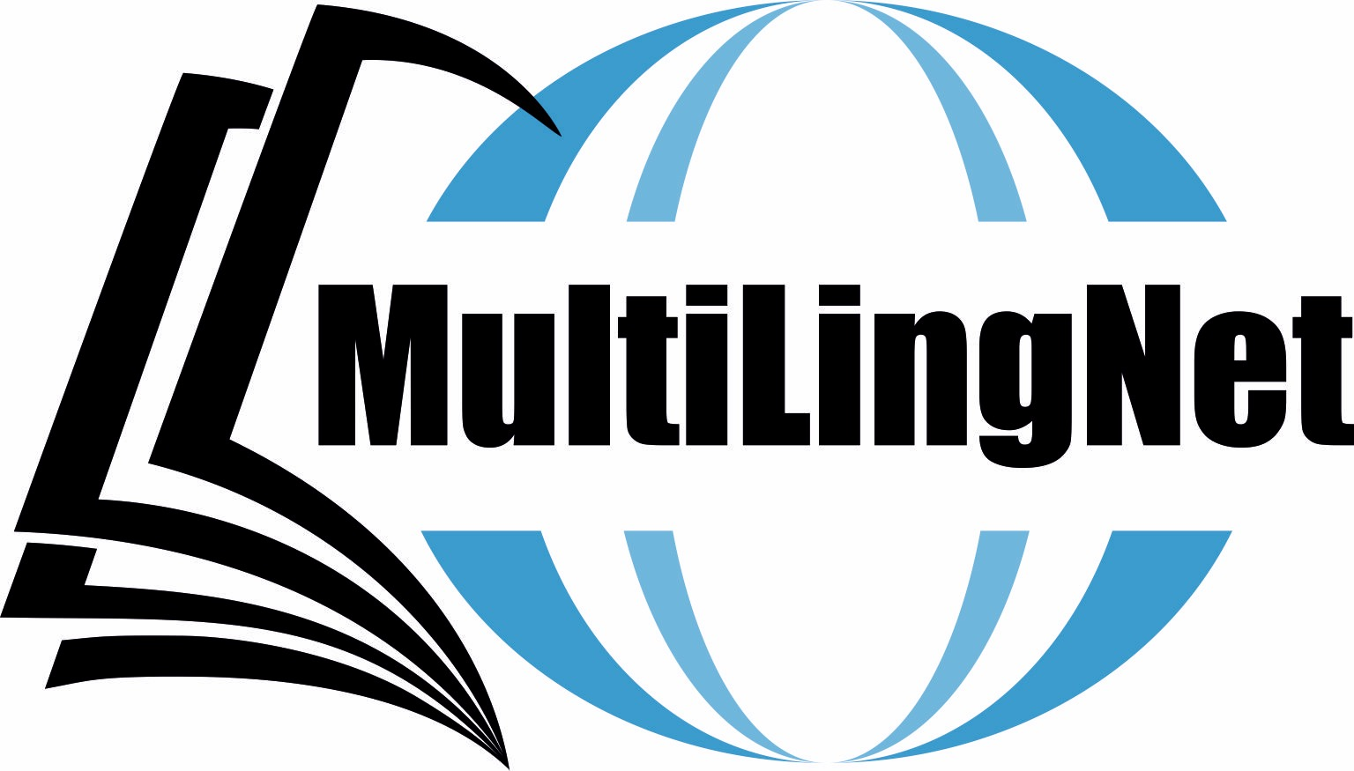

Multilingual Awareness and Multilingual Practices
MAMP18
Tallinn University, School of Humanities
ESTONIA
22-24 November 2018

The conference considers all aspects of the linguistic and sociolinguistic competences and practices of bi-/multilingual speakers who cross existing social and linguistic boundaries, adopting or adapting themselves to new and overlapping linguistic spaces.
We invite papers in all areas of research in bi-/multilingualism, whether or not linked directly to the overarching conference theme, including, but not limited to, linguistics, sociolinguistics, psycholinguistics, neurolinguistics, clinical linguistics, education, bi-/multilingual societies.

Topics will include: (multiple) language acquisition and learning (L3, L4, Lx); psycho- and neurolinguistics of multilingualism; translanguaging; early bilingualism and heritage language development; speech processing in bi-/multilinguals; trans/multilingual language use in different contexts; multilingual education; bi-/multiculturalism; bi-/multilingual language policies; literacy in multiple languages (pluriliteracy); intercultural and globalisation issues related to multilingualism; multilingual issues in literature and translation.

Confirmed speakers are: Prof. Ad Backhus (Tilburg University, Netherlands), Prof. Mila Schwartz (Oranim Academic College, Israel) and Prof. Anna Verschik (Tallinn University, Estonia).

Conference venue: Tallinn University, School of Humanities, Narva Mnt 25, 10120 Tallinn
More information on the venue is to be found here: http://www.tlu.ee/en/School-of-Humanities

The two categories of proposals are: individual papers and posters. Submission is already open and will close on 15 August 2018. Presenters are requested to submit their abstracts of up to 300 words and include their name, affiliation and email address in the MS-Word documents. All proposals should be sent to: mamp.tallinn2018@gmail.com

More information to be found: https://mamp18.wordpress.com

All presenters will be invited to submit their full papers for publication by February 2019. Selected papers will be published in a newly established journal “Journal of Bilingual Education” (www.jbe.uw.edu.pl)

