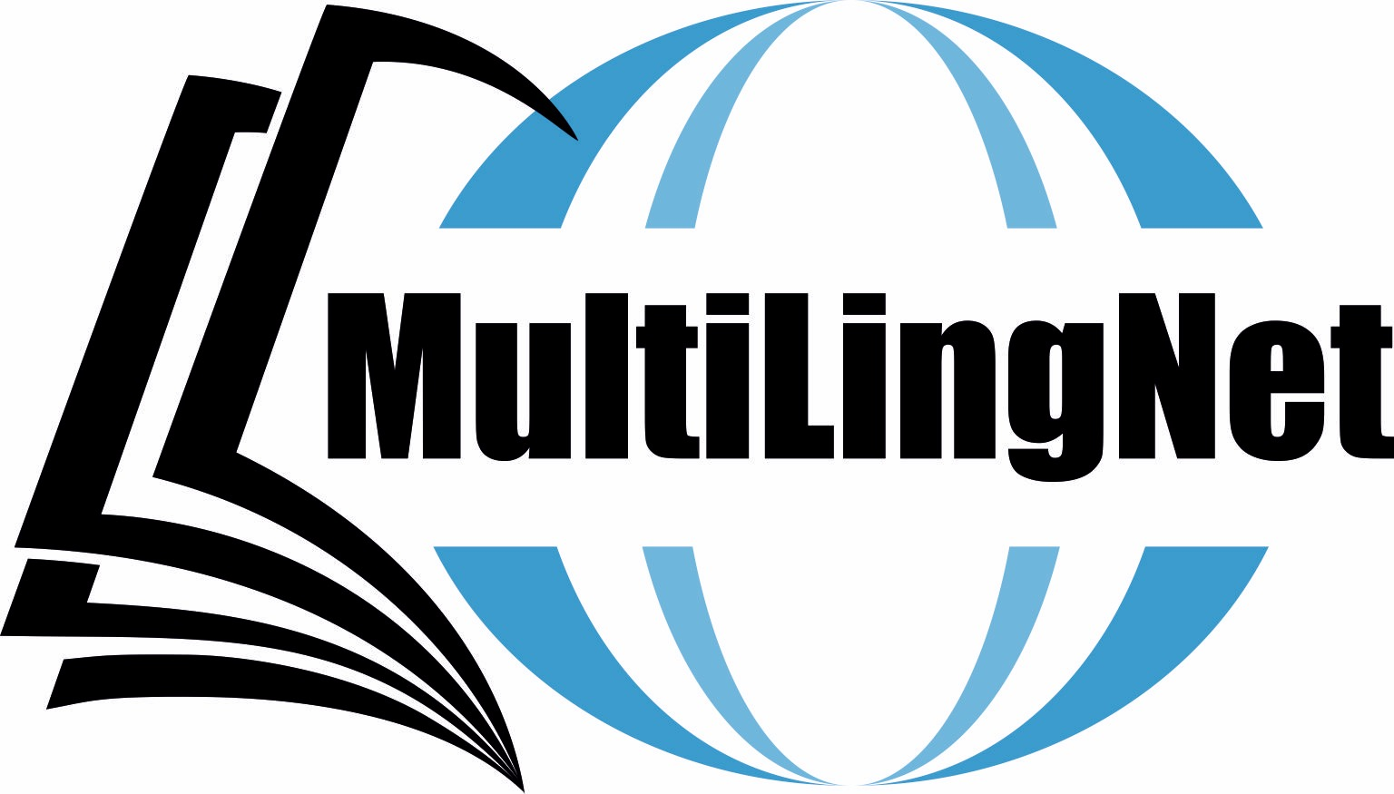

**Multilingual Education in Linguistically Diverse Contexts**

**MELDC18**

**University of Malta, Old Campus in Valletta**

**MALTA**

**30 August - 1 September 2018**

The conference considers all aspects of the linguistic and sociolinguistic competences and practices of bi-/multilingual speakers who cross existing social and linguistic boundaries, adopting or adapting themselves to new and overlapping linguistic spaces.

We invite papers in all areas of research in bi-/multilingualism, whether or not linked directly to the overarching conference theme, including, but not limited to, linguistics, sociolinguistics, psycholinguistics, neurolinguistics, clinical linguistics, education, bi-/multilingual societies.

Topics will include: (multiple) language acquisition and learning (L3, L4, Lx); psycho- and neurolinguistics of multilingualism; translanguaging; early bilingualism and heritage language development; speech processing in bi-/multilinguals; trans/multilingual language use in different contexts; multilingual education; bi-/multiculturalism; bi-/multilingual language policies; literacy in multiple 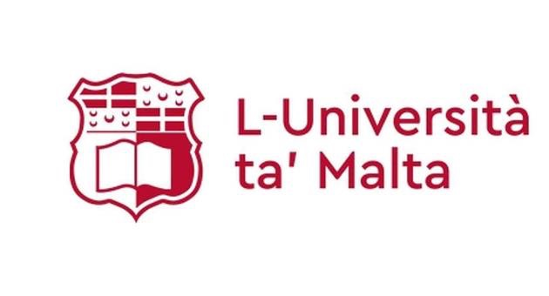languages (pluriliteracy); intercultural and globalisation issues related to multilingualism; multilingual issues in literature and translation.

Confirmed speakers are:

**Prof. Enlli Thomas** (Bangor University, Wales, UK)

**Prof. Julia Festman** (Pedagogical University Tyrol, Austria)

**Prof. Antoinette Camilleri Grima** (University of Malta).

Conference venue: University of Malta, Valletta Campus, St Paul Street VLT 1216, Malta

More information on the venue is to be found here: https://www.um.edu.mt/icp

The two categories of proposals are: individual papers and posters. Submission is already open and will close on **1 June 2018**. Presenters are requested to submit their abstracts of up to 300 words and include their name, affiliation and email address in the MS-Word documents. All proposals should be sent to: meldc2018@gmail.com

More information to be found: https://meldc18.wordpress.com

All presenters will be invited to submit their full papers for publication by April 2019. Selected papers will be published in a newly established journal “Journal of Bilingual Education” http://jbe.uw.edu.pl