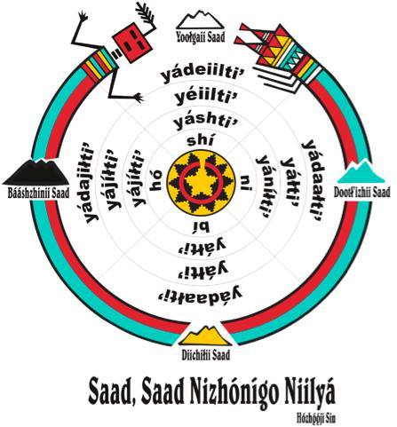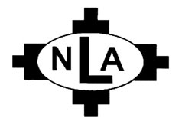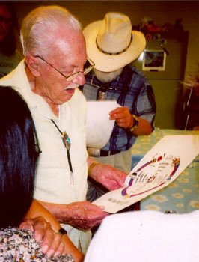

### For more information about the Navajo Language Academy visit [www.navajolanguageacademy.org](http://www.navajolanguageacademy.org) and/or email [hooghanlani@gmail.com](mailto:hooghanlani@gmail.com) for registration. Thank you

# Registration

Summer 2019 NLA Sessions:

Session I – The Navajo Verb

Session II –Navajo Reading & Writing

Lunch

Session III – Language Contact and Variation

Session IV – Learning to use the Young and Morgan dictionaries of Navajo

Session V – Research Activities

July 8th – 26th, 2019

Location:

Navajo Technical University, Crownpoint, New Mexico

Session Time: 8:30 am to 5pm

***What is NLA?*** The Navajo Language Academy, Inc. is a non-profit educational organization devoted to the scientific study and promotion of the Navajo language. The NLA is a joint effort by professional language teachers and linguists and has hosted Navajo linguistic workshops for scholars every summer since 1997. Join the Navajo Language Academy today.

**Navajo Language Academy 2019**

Navajo Language Academy, P.O. Box 5411 Window Rock, Arizona 86515