MOMS KIDEVAL ANALYSIS

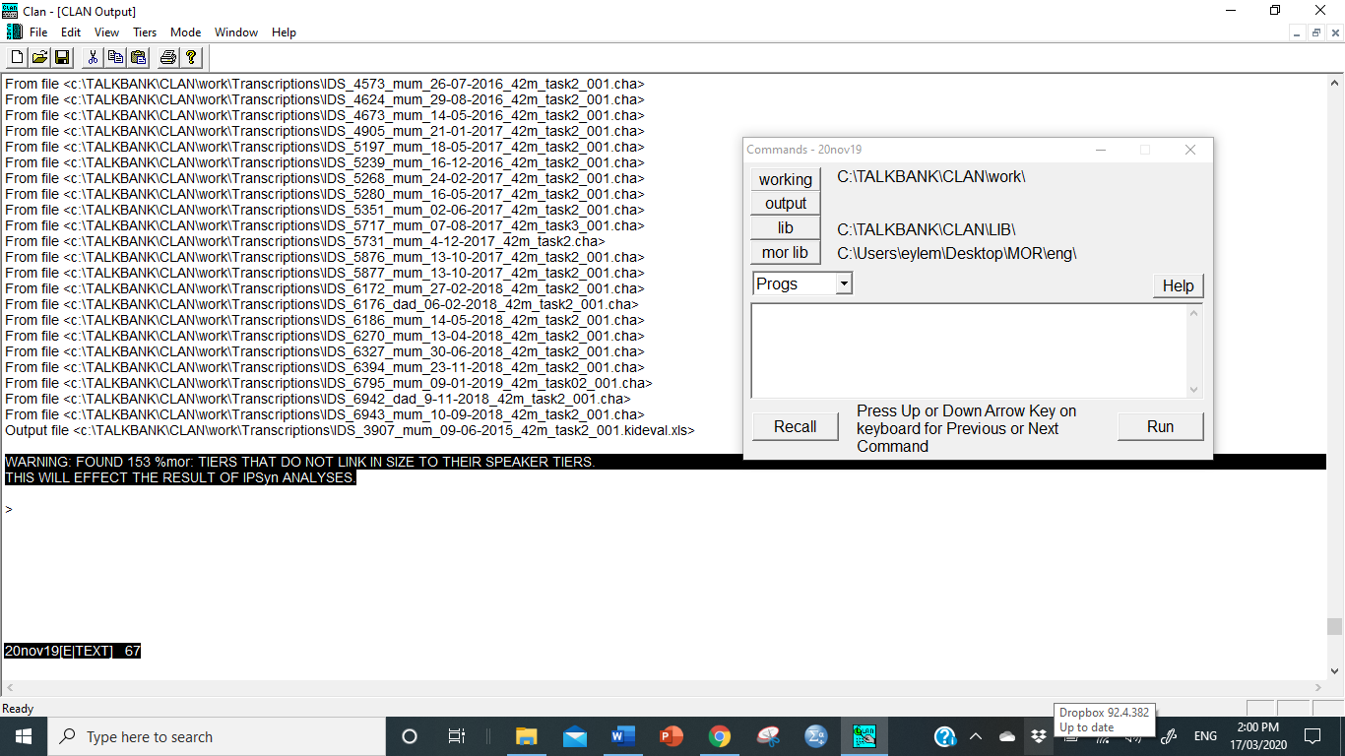

KIDS KIDEVAL ANALYSIS
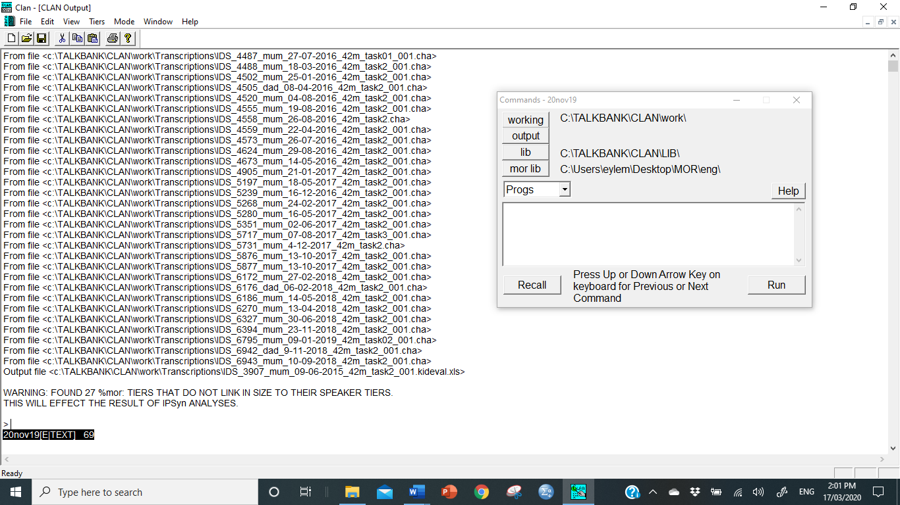

MUMS FLUENCY ANALYSIS
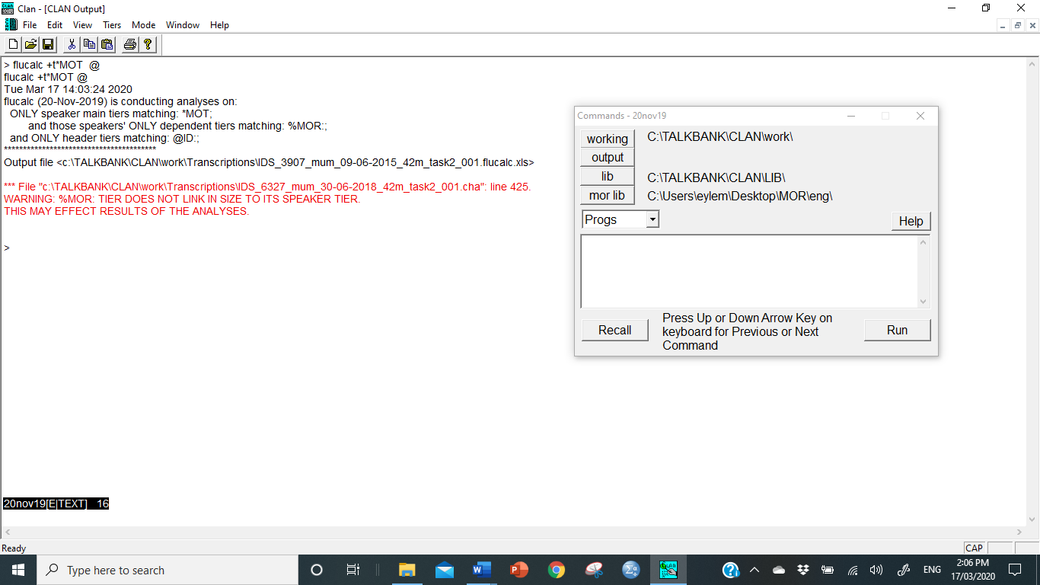

KIDS FLUENCY ANALYSIS
