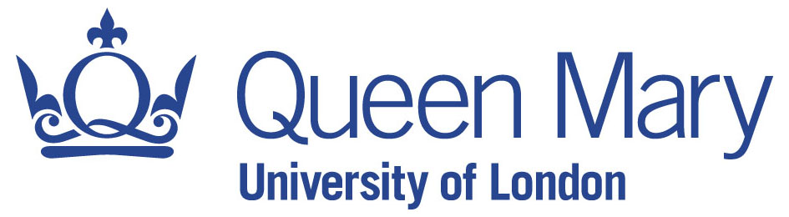

CALL FOR PAPERS

5th International Language in the Media Conference

2013 THEME: Redefining journalism: Participation, practice, change

28-30 September 2013
Queen Mary, University of London

Pre-session workshops tbc: Friday 27 September

Plenary speakers
Allan Bell (Auckland University of Technology, NZ)
Martin Conboy (University of Sheffield, UK)
Helen Kelly-Holmes (University of Limerick, Ireland)
Daniel Perrin (Zurich University of Applied Sciences, Switzerland)

This is the fifth in a biennial series of international conferences organized around the role of the media in relation to the representation, construction and production of language.*

The primary theme of the 2013 conference will be on journalism – in its many historical and contemporary manifestations – and its redefinition in the face of social media and established practice, taking its cue from the confluence of historic Fleet Street and new media and digital innovation in London.

Topics pertaining to participation, authorship, history, editorial selection, social memory, community engagement, place, and technology as it informs practice and change will underscore the theme, alongside new and traditional work on media representation, social meaning, multimodality, visual communication, genres of text and talk, and mobilities. Sociolinguistic, sociocultural, and text- or talk-related media analysis frameworks in relation to corpus linguistics, film studies, linguistic ethnography and anthropology, social semiotics, discourse analysis, and pragmatics are welcome.

Alongside this focus, the 2013 conference, as it has done from its inception in 2005, will continue to prioritize papers which address the range of sociolinguistic topics in relation to the media broadly defined: language standardization and style; literacy policy and practice; language acquisition; multilingualism and cross-/inter-cultural communication; communication in professional contexts; representations of speech, thought, and writing; language and class, dis/ability, race/ethnicity, gender/sexuality and age; political discourse, commerce and global capitalism; language and education.

We invite you to submit abstracts for papers that explore these themes.

Also on the agenda: A plenary panel of active journalists and linguists talking about what has changed in journalism and what remains the same, with an eye to inspiring future research/ers and providing new directions for investigation of language in the media.

*Background
The first two international Language in the Media conferences were held at the University of Leeds (in 2005: Language in the Media: Representations, Identities, Ideologies; in 2007: Language Ideologies and Media Discourse: Texts, Practices, Policies). The 2009 conference was at the University of Washington in Seattle (Language in the [New] Media: Technologies and Ideology). The 2011 conference was in Limerick, Ireland (Language(?) in the Media(?): Rethinking the Field).

Abstract submission
Please submit abstracts for papers via http://linguistlist.org/easyabs/LangMedia2013 no later than 30 April 2013. Abstracts should include a description of your talk (250-350 words). Notification of acceptance, following review by the conference committee, will be 15 May. Registration information will be available soon on the conference website: http://linguistics.sllf.qmul.ac.uk/LangMedia2013

Please direct any queries to Colleen Cotter at c.m.cotter (at) qmul.ac.uk

Linguistics Department
School of Languages, Linguistics and Film
Queen Mary, University of London
Mile End Road
London E1 4NS
UK

