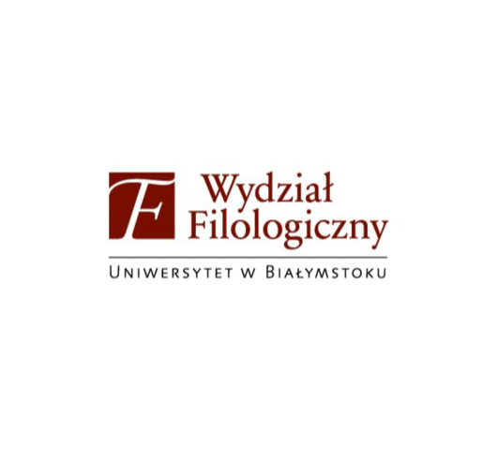 | 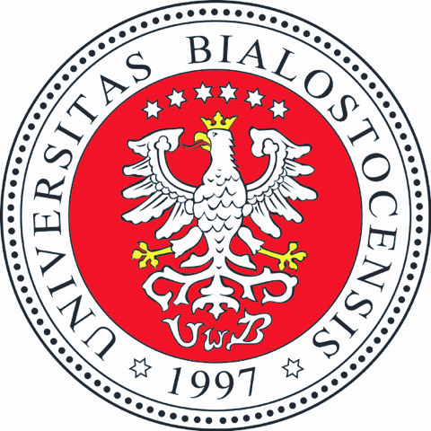

Language research at the crossroads of disciplines
the 6th Białystok-Kyiv Conference on Theoretical and Applied Linguistics
7-8 December 2023, Białystok, Poland
Conference website: https://talc.uwb.edu.pl
Twitter: https://twitter.com/TALConf

FIRST CALL FOR PAPERS
The Białystok-Kyiv series of conferences on theoretical and applied linguistics, co-organized by the University of Białystok (Poland) and the Borys Grinchenko Kyiv University (Ukraine) was launched in 2017. The main goal of the initiative is to contribute significantly to the study of language in connection with the constant changes occurring in today’s world. The organizers’ aim is to focus on various dimensions of linguistics as related to a large number of disciplines within the humanities, the social sciences, and the arts.
We are pleased to extend the first call for papers for the 6th Białystok-Kyiv Conference on Theoretical and Applied Linguistics, which will be held at the University of Białystok, Poland, 7-8 December 2023.
The conference is intended as a platform for scholars from different disciplinary backgrounds, particularly in relation to various research areas connected with language, including cognitive linguistics, contrastive linguistics, corpus linguistics, cultural linguistics, socio- and psycholinguistics, discourse analysis, language acquisition and learning, lexicology and lexicography, pragmatics, terminology and terminography, and translation studies. Proposals in other relevant research areas are also welcome. The conference is intended to explore both empirical and theoretical findings in linguistic research as well as their application in teaching.
The theme of the conference this year, Language Research at the Crossroads of Disciplines, aims to highlight the importance of interdisciplinary approaches in language research. Since language plays a crucial role in shaping our thoughts, emotions and behaviours, language research has broad implications for a variety of fields, including anthropology, education, linguistics, literature studies, neuroscience, psychology and sociology. These disciplines have traditionally approached language from different angles, focusing on various aspects of language. However, recent years have created opportunities for these disciplines to converge and collaborate, leading to exciting new insights into language. Recognising the significance of interdisciplinary collaboration, our conference is intended to bring together researchers from different fields to share their insights, methodologies, and findings.
As part of the conference, a special thematic panel, At the Crossroads of Semiotic and Linguistic Study: In Commemoration of the 120th anniversary of the Death of Ferdinand de Saussure, will take place. This panel aims to bring together all strands of semiotic study to explore the diversity of linguistic phenomena, with special emphasis placed on the multidimensionality of the sign in its both verbal and non-verbal applications in a global framework of semanticity. More importantly, however, this panel also aims to commemorate the 120th anniversary of the death of Ferdinand de Saussure, the Swiss linguist who laid the foundations for the linguistic sciences as we know them today. We would like to explore the key semiotic concepts as delimited by de Saussure against a background of other renowned semioticians' ouevres and to connect the significance of structuralist concepts with contemporary views on language. Contributions are welcome from scholars representing different linguistic and semiotic fields and disciplines, such as theoretical and applied linguistics, the philosophy of language, translation studies, biolinguistics, biosemiotics, cognitive linguistics, and cognitive semiotics.

Possible sub-themes include but are not limited to the following subject areas:

– applied cognitive linguistics,
– cognitive translatology,
– constructional and embodied approach to grammar,
– corpus linguistics,
– foreign language teaching,
– interlinguistic and intercultural pragmatics,
– first and second language learning,
– language and cognition,
– language and identity,
– language and situatedness,
– language acquisition,
– lexicography,
– semiotics,
– terminology,
– translation studies.

Proposals in other relevant research areas are also welcome.
Selected papers will be published in Crossroads: A Journal of English Studies, a Scopus-indexed journal linked to the Faculty of Philology, University of Białystok.
KEY-NOTE SPEAKERS:
- Dr Ana Frankenberg-Garcia, University of Surrey

VENUE:
The conference will be conducted as a hybrid event. Participant will be able to choose whether they want to present online or in person. The exact venue will be announced shortly.

CONFERENCE E-MAIL:
- neofilologia.uwb@gmail.com

IMPORTANT DATES:
- Deadline for the submission of abstracts (200-300 words without references): September 15, 2023
- Notification of acceptance: September 30, 2023
- Registration: October 31, 2023

Conference: December 7-8, 2023

ABSTRACT SUBMISSION:
- All proposals must be original and previously unpublished. Please include an abstract as an attachment (as a .doc/.docx file). The time allocated for each presentation is 20 minutes, with a further 10 minutes allowed for discussion.

LANGUAGE OF THE CONFERENCE:
- English

LANGUAGE OF PUBLICATION:
- English

Conference fee:
- Online presentation: 350 zlotys (approximately 75 euros)
- In-person presentation: 450 zlotys (approximately 100 euros)
The fee covers conference materials, publication of proceedings, coffee breaks, and a gala dinner.
The conference is free to attend for Ukrainian researchers.

SCIENTIFIC COMMITTEE:
- Prof. Elżbieta Awramiuk (University of Białystok, Poland)
- Prof. Zofia Chłopek ((University of Białystok, Poland)
- Prof. Elżbieta Górska (University of Warsaw, Poland)
- Prof. Anna Harbig (University of Białystok, Poland)
- Prof. Jarosław Krajka (Maria Curie-Skłodowska University in Lublin, Poland)
- Prof. Marek Łukasik (Pomeranian University in Słupsk, Poland)
- Prof. Agata Rozumko (University of Białystok, Poland)
- Prof. Irena Szczepankowska (University of Białystok, Poland)
- Prof. Magdalena Thien (University of Białystok, Poland)
- Prof. Valentyna Yakuba (BGKU, Ukraine)

ORGANIZING COMMITTEE:
- Tomasz Michta (chair)
- Michał Citko (scientific secretary)
- Paweł Dziedziul (webmaster)
- Daniel Karczewski
- Beata Piecychna
- Galyna Tsarpro
- Edyta Wajda
- Justyna Wawrzyniuk (scientific secretary)

