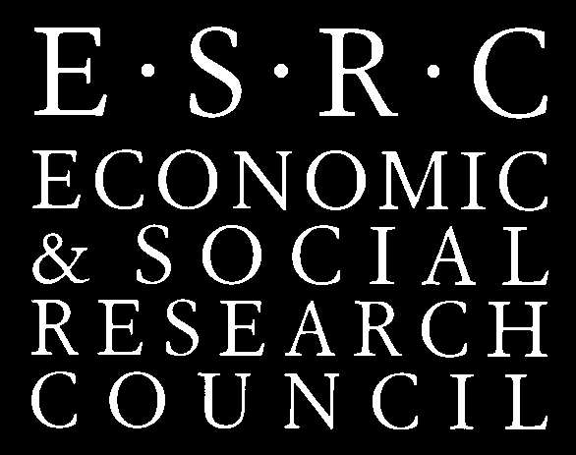

The MOSAIC Centre for Research on Multilingualism,School of Education, University of Birmingham,

Room 524, School of Education

June 11th 2012

**Bilingualism and Teacher Diversity in Schooling**

9.30 – 10.00 Registration and tea/coffee on arrival

10.00- 10.15 Opening remarks:

**Professor Angela Creese and Professor Geri Smyth**

10.15-10.45 **Dr Manka M. Varghese**, Associate Professor, College of Education, University of Washington, Seattle

*Teacher education for language minority teachers: Current issues in preparing teachers in the United States*

10.45 – 11.30 Group Discussions of plenary presentation chaired by core group member.

11.30 – 12.15 **Dr. Jean Conteh**, School of Education, University of Leeds

*Co-researching with diverse teachers: professional empowerment, theoretical exploration, implications for policy*

12.15 – 1.00 Group Discussion and plenary feedback

1.00 – 1.45 Lunch

1.45 – 2.30 **Professor Adrian Blackledge**, MOSAIC Centre for Research on Multilingualism, University of Birmingham

*Diversity, superdiversity, and beyond*

2.30 – 3.15 Discussion of Plenary

3.15 – 4.00 Seminar Discussant: **Dr. Vini Lander**, University of Chichester.

Whole group discussion and close.