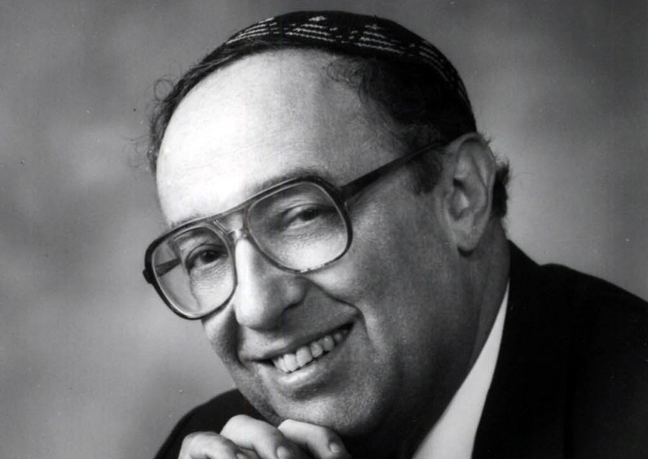

THE LIFE AND LEGACY OF JOSHUA FISHMAN:
Seminal Contributions to Sociolinguistics and Human Development

Friday, April 8, 2016, 12:00 to 2:00pm, Convention Center, Level Two, Room 202B
This Symposium will include distinguished scholars who have worked with Joshua Fishman or have published theory or research in the area of sociolinguistics that grows Fishman’s scholarship. We will examine Fishman’s work and address the multitude of ways it continues to influence language research, social issues, sociolinguistics, anthropology, educational linguistics, bilingualism--with attention to research about discourse, schools and schooling. The presentations will take a variety of forms—recollections of papers that influenced their thinking, how they and their students have used his theoretical discussions, and address directions that are still needed.
Sponsors: The American Education Research Association Headquarters in cooperation with The Center for Applied Linguistics, and the SIG on Research in Reading and Literacy (Rosalind Horowitz, Chair; Francine Falk-Ross, Program Chair)
Co-Sponsors: Division B, Curriculum Studies; SIG: Writing and Literacies, SIG: Bilingual Education Research; SIG: Second Language Research; SIG: Language and Social Processes
Speakers:
Rosalind Horowitz, Session Organizer,
The University of Texas—San Antonio
Ofelia Garcia, Teachers College, Columbia University
Terrence Wiley, Center for Applied Linguistics
Nancy Hornberger, University of Pennsylvania
Kenji Hakuta, Stanford University
Stanton Wortham, University of Pennsylvania
Asya Vaisman Schulman, The Yiddish Book Center
Closing Remarks:
Rosalind Horowitz, The University of Texas—San Antonio
Reception to Follow

