Please consider submitting your manuscript to:

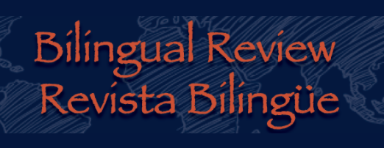

Web page: bilingualreviewjournal.org

The Bilingual Review/Revist*a Bilingue* is a peer-reviewed academic journal focusing on the linguistic, cultural, and literary diversity of cultures in contact, especially within Latinx communities in the US.  The Bilingual Review/Revista Bilingüe publishes both empirical (qualitative and quantitative) as well as creative scholarship.  The BR/RB will feature empirical research in the areas of bilingualism, biliteracy, critical applied linguistics, the social context of bilingual dual language education, raciolinguistic perspectives, and ethnic scholarship. To engage the readership with multiple forms of representation, we seek out scholarly activity expressed through the literary and visual arts. The BR/RB accepts a variety of genres including scholarly articles, short stories, poetry, art, literary criticism, and book reviews, in English or Spanish and across Spanish and English.

**Editor**, Dr. Christian Faltis, Texas A&M International University. Christian.faltis@tamiu.edu

**Associate Editor**, Dr. Lourdes Viloria, Texas A&M International University. Maria.viloria@tamiu.edu

**Associate Editor**, Dr. Deborah Palmer, University of Colorado, Boulder. [Debpalmer@colorado.edu](mailto:Debpalmer@colorado.edu)

**Editorial Board**

Elaine Allard, Swarthmore College, Pennsylvania.

Adriana Álvarez, University of Colorado, Denver

Alfredo Artiles, Stanford University

Blanca Caldas Chumbes, University of Minnesota, Twin Cities

David Degollado, University of Iowa

Cecilia Espinosa, City University of New York, Lehman College

Nelson Flores, University of Pennsylvania

Suzanne García-Mateus, California State University, Monterey Bay

Ramón Antonio Martínez, Stanford University

Theresa Montaño, California State University, Northridge

Idalia Núñez-Cortez, University of Illinois, Champaign-Urbana

Amelia Tseng, American University, Washington D.C.

Joanna Wong, California State University, Monterey Bay