ADDENDUM 1
4th World Congress of Finno-Ugric Peoples  Tallinn, August 15 to 19, 2004 | 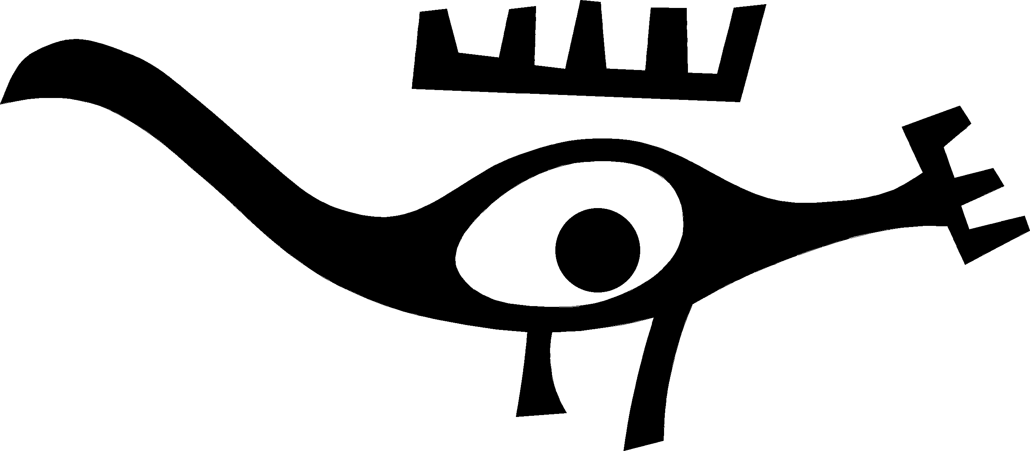
The Youth Is Our Future

The 4th World Congress of Finno-Ugric Peoples is organised by Fenno-Ugria Foundation.
The Patron of the Congress is Mr Arnold Rüütel, President of the Republic of Estonia.

Participants of the Congress
In accordance with the representation quotas (3 to 20 delegates per people according to the population), over 300 official delegates will participate in the World Congress of Finno-Ugric Peoples in Tallinn.
An approximate equal number of observers and guests is expected, including the representatives of the governments of Hungary, Estonia and Finland as well as the territorial administrations of countries with a Finno-Ugric population. Adding the invited guests from international organisations (UNESCO, UN ECOSOC, Council of Europe, the Nordic Council of Ministers) and journalists, the estimated number of participants is 600 to 700.

Representation quotas (delegates per people)
Peoples | Territories
BALTIC-FINNIC PEOPLES
Estonians | Estonia | 20
Setos | Estonia, Pskov Oblast | 3
Votians | Southern bank of the Gulf of Finland in Leningrad Oblast | –
Livonians | Kurzeme Peninsula, Riga and other cities | 3
Finns | Finland | 20
Kvens | Norway, Finnmark | –
Meänkieliset (Tornedal Finns) | Sweden, Norrbotten | –
Ingrian Finns | Vicinity of St. Petersburg, Estonia, Finland | 10
Izhorians | Vicinity of St. Petersburg, southern bank of the Gulf of Finland | 3
Karelians | Republic of Karelia and Leningrad Oblast | 20
Tver Karelians | Tver Oblast | 20
Vepsians | Republic of Karelia, Leningrad Oblast, Vologda Oblast | 10
SAAMIS | Central and northern Norway, Finland and Sweden, Kola Peninsula | 20
VOLGAIC PEOPLES
Erzya-Mordvins | Republics of Mordovia, Bashkortostan, Chuvashia and Tatarstan, Nizhny Novgorod Oblast, Samara Oblast, Penza Oblast and Orenburg Oblast | 20
Moksha-Mordvins | Republics of Mordovia and Tatarstan, Samara Oblast and Penza Oblast | 20
Maris | Republic of Mari El and vicinity, Republics of Bashkortostan and Tatarstan, Yekaterinburg Oblast and Perm Oblast | 20
PERMIAN PEOPLES
Udmurts | Republic of Udmurtia and vicinity | 20
Besermens | Republic of Udmurtia | –
Zyrian Komis | Republic of Komi, Kola Peninsula, Western Siberia | 20
Permian Komis | Permian Komi Autonomous District | 20
UGRIAN PEOPLES
Khants | Khanty-Mansi and Yamal Nenets Autonomous Districts and Tomsk Oblast in Western Siberia | 10
Mansis | Khanty-Mansi Autonomous District in Western Siberia, Yekaterinburg Oblast | 10
Hungarians | Hungary, Romania, Slovakia, Ukraine, Austria, Croatia and elsewhere | 20
SAMOYED PEOPLES
Nenetses | Nenets, Yamal Nenetsi and Taimyr Autonomous Districts, Khanty-Mansi Autonomous District | 10
Nganasans | Taimyr Peninsula in Siberia | 3
Selkups | Between the rivers of Ob and Yenisey in Western Siberia | 3
Enetses | On the lower course of the Ob in Northern Siberia, Taimyr Autonomous District | –

Finno-Ugrians not yet represented
• Votians – lacking a central society, Votians have not been represented at previous Congresses. One Votian participated in the 2nd Congress in Budapest as a member of the Ingrian Finnish delegation.
• Kvens and Meänkieliset (Tornedal Finns) – their languages have previously been considered dialects of Finnish but today, Sweden recognises Meänkieli (Tornedal Finnish) as an independent minority language and Norway recognises Kvens as a minority. Both the Meänkieliset (Tornedal Finns) and the Kvens participated in the Helsinki Congress (2000) as observers.
• Besermens – speak a language close to Northern Udmurtian. Have not been represented at the Congress, as they were recognised to be a separate people only in the last population census in Russia (2000)
• Enetses – unrepresented because of a small population and the lack of a central society.
All these peoples may apply for participation until February 2004.

General conditions of work at the Congress

Working languages
Official working languages of the Congress are Russian and English. As wished by the organising country, plenary presentations and speeches are interpreted into Estonian. For the first time in the history of the Congress, the working languages of the 4th Congress include all Uralic languatges: plenary presentations by all peoples are held in the respective ethnic languages. The work of Sections will be carried out in English and Russian.

Plenary sessions
The Congress will be opened and closed by a plenary session. The opening plenary session will include the addresses by the Presidents of the three Finno-Ugric nation states and the President of the Russian Federation, speeches by government representatives and guests, addresses by the heads of delegations. The closing plenary session will pass the Resolution of the Congress.

Sections
The work of the Congress will be conducted in five Sections. Each Section will present recommendations of its field of competence to the Consultative Committee of Finno-Ugric Peoples. The Sections of the World Congress are
• Social and Political Issues
• Language and Education;
• Culture;
• Health, Demography and Ecology;
• Media and Information Systems.

A selection of the topics to be discussed
1. Social and Political Issues:
• Decision-making and the forming of internal policies in the territories of Finno-Ugric peoples
• Language policies
2. Language and Education:
• Language development strategies and planning
• Contemporary bilingual and multilingual education
• Language culture, purity of language, the ecosystem of language and terminology

3. Culture:
• Cultural policies in Finno-Ugric regions
• Traditions of Finno-Ugric peoples, innovation. Ethno-futurism: ideology and management
• Cultures of Finno-Ugric peoples as a developing resource of the social economy of Russian regions
4. Health, Demography and Ecology:
• health of Finno-Ugric and Samoyed youth
• social and emotional environment of Uralic indigenous peoples
5. Media and Information Systems:
• Radio and television programmes for youth and children in Finno-Ugric and Samoyed languages
• Uralic youth media, its situation and perspectives
• Creating an ethnic linguistic and cultural environment in the Internet.

The Venues of the Congress
The plenary sessions of the 4th World Congress of Finno-Ugric Peoples will be held in the concert hall of the Estonia Theatre. The concert hall has enormous importance in the Estonian culture and is well loved by the general public. The Estonia concert hall was the venue of the sessions of the Constituent Assembly of the Republic of Estonia from 1919. The Assembly passed the Constitution of the Republic of Estonia in the same hall. In 1990, the Estonian Congress was held in the Estonia concert hall.
The sections of the World Congress are planned to take place in the new Conference Centre of the Hotel Viru.

Compiled by

Andres Heinapuu
Secretary General of the 4th World Congress of Finno-Ugric Peoples
Manager of the Information Centre of Finno-Ugric Peoples

