ADDENDUM 3

World Congress of Finno-Ugric Peoples  General Information | 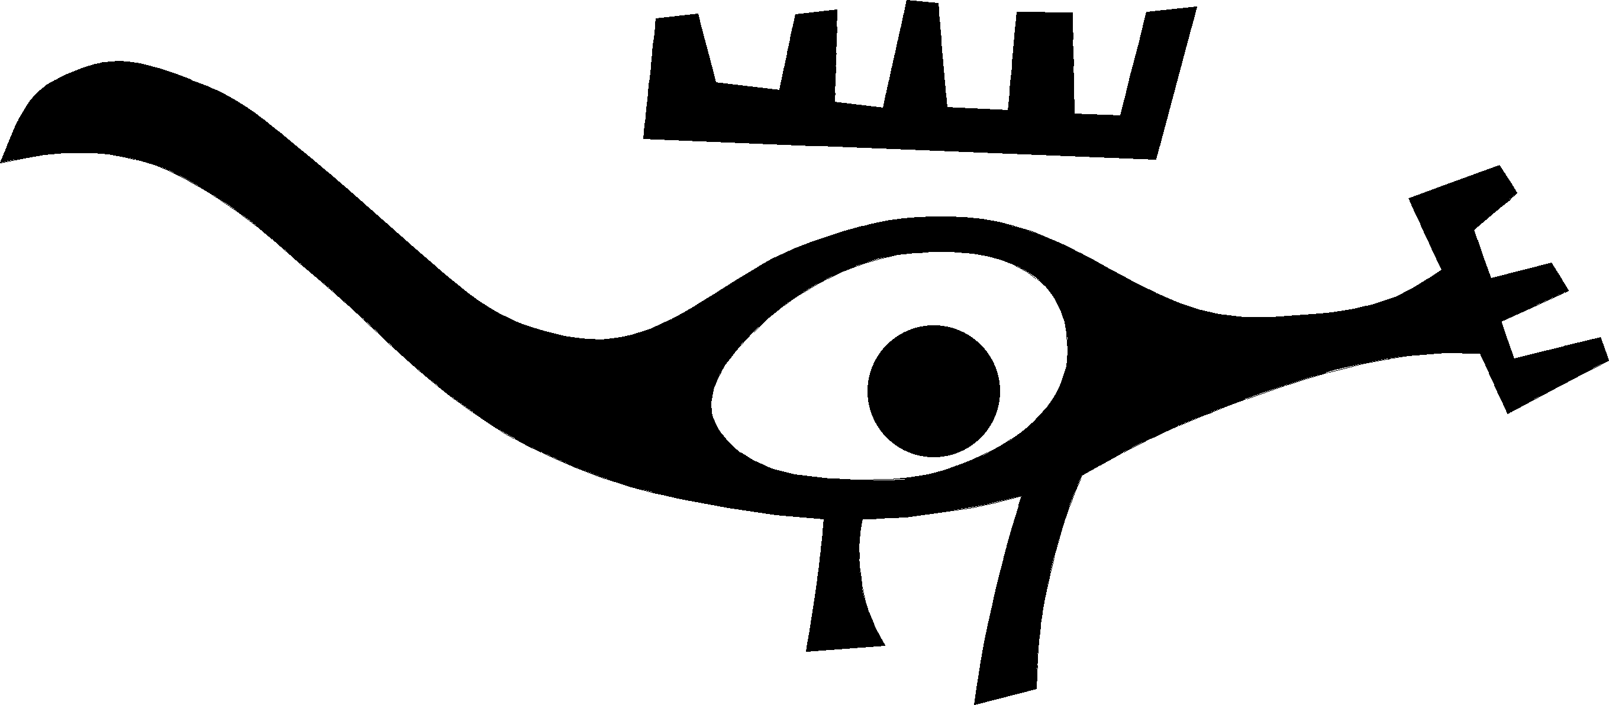

According to Declaration of Fundamental Principles, Aims and Objectives of Cooperation of Finno-Ugric Peoples of the World, “the World Congress of Finno-Ugric Peoples is a forum of Finno-Ugric and Samoyed Peoples. It is independent of governments and political parties, and aims for the status of a non-governmental organization of the UN Organization” (Syktyvkar, 1992).
The Consultative Committee of Finno-Ugric Peoples as the executive body of the Congress represents the Congress at the Working Groups On Indigenous Populations of the United Nations Commission on Human Rights.

The aims of the Congress are
To develop and protect the ethnic identities, cultures and languages of Finno-Ugric peoples; to promote the cooperation between Finno-Ugric peoples; to discuss and find solutions to their most urgent problems; and to promote the implementation of their right to self-determination in accordance with the norms and principles of the international law.

Consultative Committee of Finno-Ugric Peoples and the World Congress of Finno-Ugric Peoples

Principles of work, functions and powers
The delegations of peoples at the Congress and the representatives of peoples in the Consultative Committee are appointed by national congresses of the peoples in question or in the absence of a national congress, by central national or cultural societies.
The representatives of Estonia are appointed by Fenno-Ugria Foundation, the representatives of Finland by the Finland-Russia Society (Congress delegations are formed in co-operation with the M. A. Castrén Society), the representatives of Hungary by the Hungarian Society of the World Congress of Finno-Ugric Peoples.
 | World Congress | Consultative Commitee
Assembly | Once every four years | Two sessions a year
Representation quotas | 3 to 20 delegates per people according to population; one vote per people.  As an exception, Tver Karelians have a representation but share their vote with the Karelians of Karelia; Ingrian Finns have a representation and a vote. | Up to 2 representatives per people; one vote per people.  Exceptions same as those on Congresses. Voting is carried out only in issues concerning the management of the organization; substantive decisions are reached by consensus.
Management | Preparatory work is carried out and the project of the agenda as well as of the documents are presented by the Consultative Committee.  Sessions are chaired by a working presidium with representatives from Russia, Hungary, Finland and Estonia (one each; these being, in practice, the coordinators of the Consultative Committee) | By customary practice, the Chairman is from the Russian Federation (currently Mr. Valery Markov representing the Komi people). The Chairman and the three coordinators (representing Hungary, Finland, Estonia and Livonians) form the Secretariat of the Committee.  The Secretariat is responsible for preparing the agenda of the sessions of the Committee.
Functions and powers | • hears and approves the report of the Consultative Committee  • passes decisions, declarations and resolutions  • Sections pass recommendations | • fulfils the resolutions of Congresses  • follows the recommendations of Sections in its current work  • manages co-operation between Finno-Ugric peoples

Previous Congresses
1992 – 1st World Congress of Finno-Ugric Peoples in Syktyvkar, the capital of the Republic of Komi (the Russian Federation). Main organiser: the Committee for the Renaissance of the Komi People. The 1st Declaration for the Co-operation of Finno-Ugric Peoples passed.
1996 – 2nd World Congress of Finno-Ugric Peoples in Budapest, organised by the Hungarian Society of the World Congress of Finno-Ugric Peoples. The plenary session of the Congress, opened by the President of Hungary, was held in the Parliament of Hungary. For the first time, work in sections took place. The Sections passed their recommendations for the Consultative Committee of Finno-Ugric Peoples.
2000 – 3rd World Congress of Finno-Ugric Peoples in Helsinki, Finland. The sessions were held in the Finlandiatalo. The main organiser was the Finland-Russia Society in co-operation with the M. A. Castrén Society. The Congress was first time visited by the Presidents of all Finno-Ugric nation states (Estonia, Hungary, Finland). The greeting by the President of the Russian Federation was presented by Mr. Blokhin, Minister of Ethnic Affairs. Mr. Lennart Meri, President of Estonia, presented the participants with an invitation to take part in the next Congress in Tallinn in 2004. The President emphasized the need for future co-operation between the Finno-Ugric family of peoples.

The honour and obligation to organize the 4th World Congress of Finno-Ugric Peoples has been passed on to Estonians. The main theme of the Congress to be held in Tallinn from August 15 to 19, 2004 is Youth – the Hope and Future of Finno-Ugric Peoples. The Patron of the Congress is Mr Arnold Rüütel, President of the Republic of Estonia.
The fact that the Congress will be held in Tallinn is of enormous importance to Estonia. This will allow consolidating and diversify cultural exchange with all Finno-Ugric peoples. As the Finno-Ugric peoples form the ‘cultural rear’ of Estonians, they will help us define ourselves culturally in Europe.

Compiled by

Andres Heinapuu
Secretary General of the 4th World Congress of Finno-Ugric Peoples
Manager of the Information Centre of Finno-Ugric Peoples

