
4th World Congress of Finno-Ugric Peoples

YOUTH IS OUR FUTURE
Tallinn, August 15 to 19, 2004

INVITATION

The 4th World Congress of Finno-Ugric Peoples will take place in Tallinn from August 15 to 19, 2004. For the first time, the Congress will be dedicated to the key questions on the survival of small peoples.
As the organisers of the 4th World Congress of Finno-Ugric Peoples, we have the honour of inviting You to our Congress as an observer.
The world's richness of cultural diversity can only survive if all nations' and tribes' traditional knowledge (including linguistic competence) will be transferred to the next generation. The 4th Congress of Finno-Ugric Peoples will concentrate on possibilities and means for the younger generation to preserve and upkeep the links with their roots as well as maintain a positive relationship with the changing world without losing the features of their own culture.
The World Congress of Finno-Ugric Peoples is the highest representative body of Finno-Ugric peoples.
As the time of the Congress coincides with the ending stage of the United Nations Decade of Indigenous Peoples, the Congress on Finno-Ugric youth is fit to symbolise the co-operation and wish for survival of small peoples. We will also glance at the future prospective of our family of peoples.
Various cultural events are scheduled to take place during the Congress, including the day of presenting successful indigenous projects preceding the official beginning of the Congress. We ask you to contribute to Successful Projects Day with your relevant presentation if possible (please note the theme).
The participation fee for observers is 50 euros. This will include all the events of the Congress but excludes accommodation in Tallinn during the Congress. The organisers of the Congress are willing to aid you in booking a hotel room (see hotel approximate hotel prices on the registration form).
If you wish to partake the 4th World Congress of Finno-Ugric Peoples, please inform us by April 30, 2004.
The participation fee should be transferred to the bank account of Fenno-Ugria Foundation (Hansapank 221024071454; S.W.I.F.T. code HABA EE2X) by April 30, 2004.

On behalf of the organisers
With best wishes,

Andres Heinapuu
Secretary General of the 4th World Congress of Finno-Ugric Peoples

Addenda:
- The 4th World Congress of Finno-Ugric Peoples
- The schedule of the 4th World Congress of Finno-Ugric Peoples
- World Congresses of Finno-Ugric Peoples
- The Day of Performances
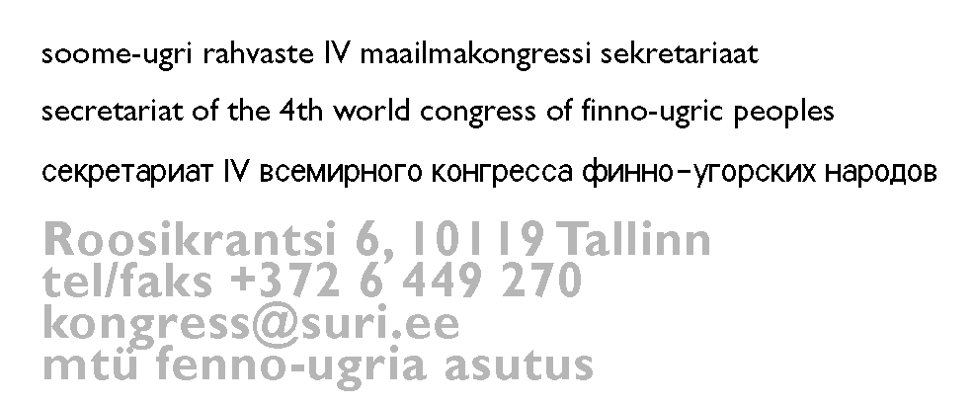
- Registration form for observers

