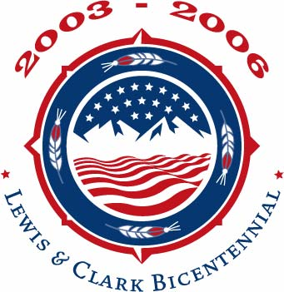

For Immediate Release
Contact:

Sammye Meadows
National Council of the Lewis & Clark Bicentennial
Circle of Tribal Advisors 970.641.1355 jermond@pcrs.net
Doug Whalen Endangered Language Fund
203.772.1446, ext. 234
David Westcott
Oregon Community Foundation
541.431.7099
DavidW@ocf1.org

Everett Dietle
Missouri Historical Society
314.454.3178
ead@mohistory.org

whalen@haskins.yale.edu

ANNOUNCING NATIVE VOICES ENDOWMENT:

A LEWIS & CLARK EXPEDITION BICENTENNIAL LEGACY
A new program to help stem the loss of American Indian languages

(SAINT LOUIS, MO, January 8, 2007): The National Council of the Lewis & Clark Bicentennial, the Circle of Tribal Advisors (COTA), and the Missouri Historical Society (MHS) announced today the creation of a critical bicentennial legacy, established in coast-to-coast partnership with the Endangered Language Fund and the Oregon Community Foundation. The Native Voices Endowment: A Lewis & Clark Expedition Bicentennial Legacy is a $1.6 million endowment fund, established to advance education and revitalization of endangered Native languages for tribes along the Lewis & Clark National Historic Trail.

The endowment is funded with surcharge proceeds received by the National Council and MHS on sales of the U.S. Mint’s 2004 Lewis & Clark Commemorative Coin, including a limited edition coin and American Indian handmade pouch set.

The donors selected the Endangered Language Fund (ELF) of New Haven, Connecticut, to manage the $1.6 million endowment’s grants program and the Oregon Community Foundation, a national four-star charity, to manage investment of the endowment’s funds. ELF will use the endowment’s annual earnings to make grants of $2,500 to $25,000 to tribal community and tribal school language programs and scholars. The first grant cycle will begin in late 2007.

ELF will be advised by a committee of three widely recognized Native language authorities. Members of the inaugural advisory committee are Darrell Robes Kipp, Blackfeet, founder of the Piegan Institute for the Blackfeet language in Browning, Montana; Dr. David M. Gipp, Standing Rock Sioux, President of United Tribes Technical College in Bismarck, North Dakota; and Philip Cash Cash, Cayuse/Nez Perce, linguist.

---more---

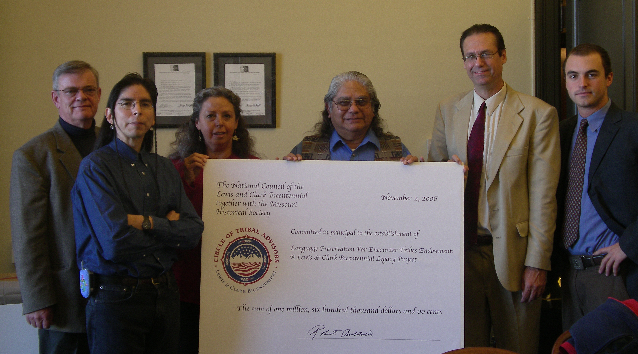

L to R: Dr. Robert Archibald, Philip Cash Cash, Roberta Conner, Allen V. Pinkham, Sr., Douglas
Whalen, Nick Emlen

The worldwide crisis in Indigenous language loss is severe. Scholars estimate that 90% of the world's languages are now spoken by only 10% of the world’s population. Unfortunately, many American Indian ancestral languages have already been lost. 80% of those that remain are no longer being learned by children. Even American Indian languages that were strong two decades ago are now endangered, and many will die out when the remaining elders who speak them are gone.

According to Douglas Whalen, founder and president of the Endangered Language Fund, “There are currently 6,000 languages spoken in the world, and at least half are projected to disappear in this century. ELF and the Native Voices Endowment intend to help stem that tide for Native languages on the Lewis & Clark Trail. This is an exciting opportunity for greater empowerment within Native communities to support work on their tribal languages.”

“The Oregon Community Foundation is very pleased and honored to hold this important new fund in support of American Indian ancestral languages,” said Gregory A. Chaillé, President of the Oregon Community Foundation. “The Lewis & Clark Bicentennial provided Oregon with a wonderful opportunity to examine how best to preserve, understand and learn about our common heritage. We can’t think of a better way to honor the hard work of the Circle of Tribal Advisors than by helping to establish this permanent endowment.”

Advisory committee member Darrell Kipp noted, “Of all the arts and sciences created by humankind, none equals a language, for only a language in its living entirety can describe a unique and irreplaceable world. American Indian languages are libraries of ancient knowledge. When a language dies, that wisdom is lost forever.”

---more---

Chairman of COTA, Allen V. Pinkham, Sr., Nez Perce, echoed those thoughts, “Tribal languages present a whole different world view than English. They contain time tested ways of looking at things that can hold answers for everybody’s future.”

During the Lewis & Clark Bicentennial Commemoration, one of COTA’s most important goals was to raise public awareness about the crisis in Native language loss. George Heavy Runner, National Council board member, Blackfeet representative to COTA and member of the COTA Leadership Committee, felt that the endowment gives tribes the ability to go beyond raising awareness, “After two hundred years, the Lewis & Clark Bicentennial has given back to Native Peoples along the trail an opportunity to preserve more than just memories of the past, but opportunities for the future.”

According to Dr. Robert R. Archibald, president of the National Council of the Lewis & Clark Bicentennial and the Missouri Historical Society, “Extinction of Indigenous languages impacts everyone. The Mandan language – whose speakers imparted such a wealth of information to Lewis & Clark – is now spoken only by five or six elderly people. Think of the information about ecosystems, diplomacy, agriculture, trade and much more that could be lost forever if strong language perpetuation programs are not funded before those speakers are gone. The Native Voices Endowment gives us a chance to make a difference far beyond the Lewis & Clark Bicentennial.”

More complete information about the Native Voices Endowment and its grant guidelines can soon be found at www.endangeredlanguagefund.org.

For more information about the National Council of the Lewis & Clark Bicentennial and the Circle of Tribal Advisors, go to www.lewisandclark200.org.
For more information about the Missouri Historical society, go to www.mohistory.org.
For more information about the Endangered Language Fund, go to www.endangeredlanguagefund.org.
For more information about the Oregon Community Foundation, go to www.ocf1.org.

#####

