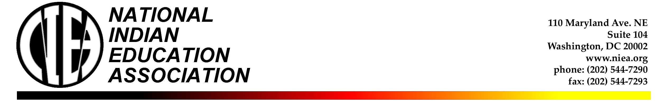
National Indian Education Association
Revitalizing Native Language Research Scholarship
***DEADLINE EXTENDED***

The NIEA and Professor Lily Wong Fillmore solicits application for graduate student research on revitalizing Native language research.

($1,000 for one academic school year)

Scholarship Criteria & Guidelines:
- Graduate student-researcher must be American Indian, Alaska Native or Native Hawaiian
- Student must be engaged in the documentation or study of a language revitalization effort in an indigenous community or in a school serving indigenous students
- Enrolled full-time in an accredited college/university master’s or doctorate program that incorporates studying the revitalization of an indigenous language.
- Demonstrate leadership qualities
- Maintain high academic achievement
- Serve as a role model for other students
- Demonstrate creativity in commitments in the following areas:
  - Promote an understanding and appreciation for native language revitalization
  - Demonstrate positive, active student leadership within the school or indigenous community they are serving
  - Demonstrate and/or encourage peer student and indigenous community involvement in revitalizing indigenous languages

Application Process:
- Utilize existing application procedure/form for the Rouillard/Tonemah Scholarship.
- Find application at www.niea.org
- Applications due January 20, 2007 (NEW DEADLINE)

