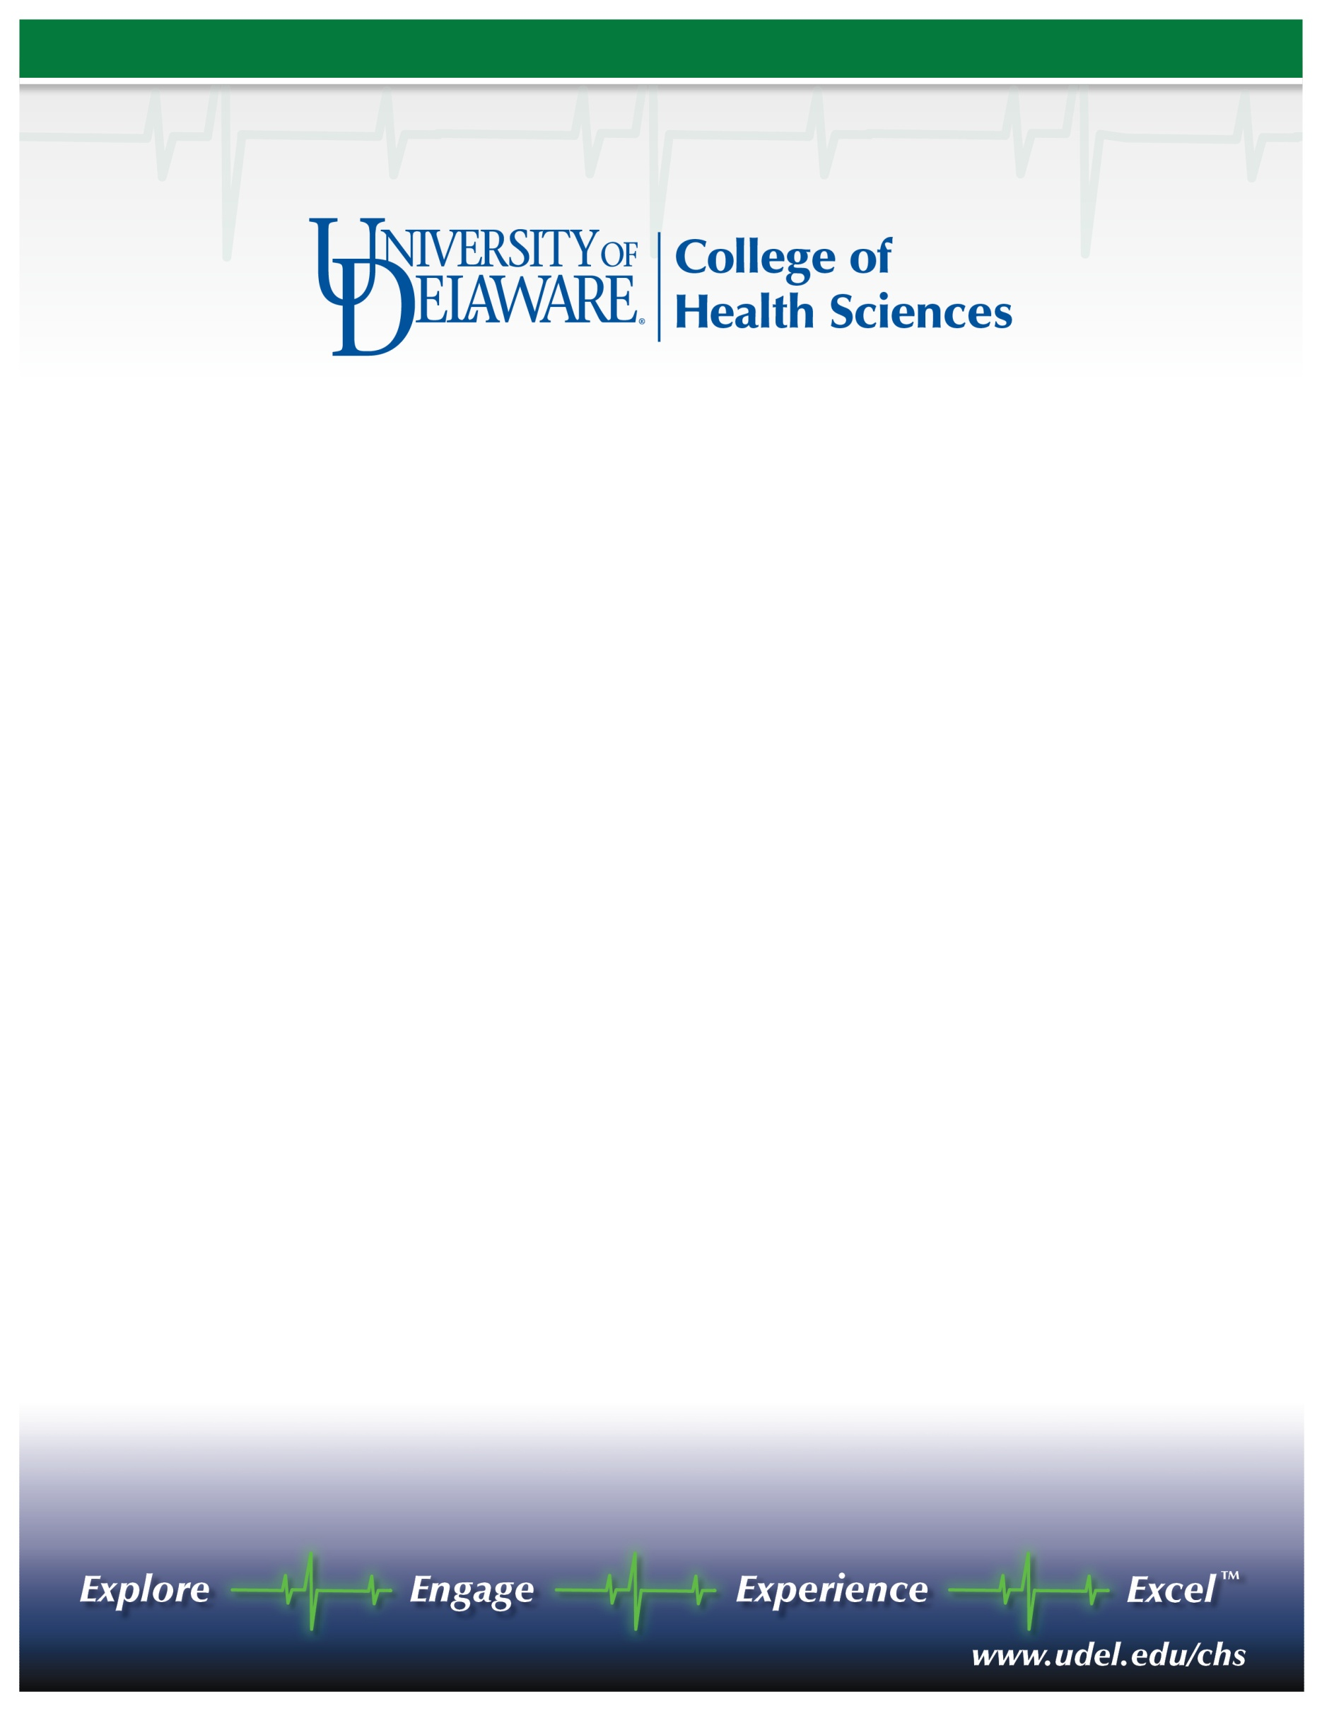

FOUNDING DIRECTOR
M.A. PROGRAM IN SPEECH-LANGUAGE PATHOLOGY
Appointment effective September 1, 2014

The College of Health Sciences at the University of Delaware invites nominations and applications for a Founding Director to lead a new M.A. program in Speech-Language Pathology. The development of the University’s new Science, Technology, and Advanced Research (STAR) campus enables building state-of-the-art instructional and clinical facilities to support this program, which is projected to launch in Fall 2016. We seek a visionary scholar who can provide strong, dynamic, and innovative leadership to build an outstanding, nationally recognized program. A strong record of scholarship; commitment to professional education; ability to build effective collaborations across faculty and academic units; knowledge of ASHA accreditation standards and procedures; strategic budget planning experience; and strong management and interpersonal skills are required. Candidates must have an earned doctorate in speech-language pathology or a related field and be qualified for tenure at the associate or professor level.

The College of Health Sciences is an innovative, interdisciplinary college of more than 2,000 students and 100 faculty. The College prepares students for leadership careers in physical therapy, nursing, medical laboratory sciences, athletic training, nutrition, behavioral health, and exercise science as well for graduate and professional studies in medicine, physical and occupational therapy, dentistry, physician assistant, and pharmacy. Our state-of-the-art Health Sciences Complex on the STAR campus brings together researchers, clinicians, and students to address some of the most critical healthcare questions of our time. The yet to be developed speech-language pathology facilities will have close adjacency to the College’s existing physical therapy and nurse-managed health clinics.

Founded in 1743, the University of Delaware combines tradition and innovation, offering students a rich heritage along with the latest in instructional and research technology. Located in scenic Newark, Delaware, within 2 hours of New York, Philadelphia, Baltimore, and Washington, D.C., the University is a Land Grant, Sea Grant, Space Grant, Carnegie Research University (very high research activity), with external funding exceeding $200 million. A state-assisted, privately-governed institution, the University enrolls approximately 17,000 undergraduates and 4,000 graduate students.

Salary is competitive, commensurate with experience and qualifications. Faculty and administrators have received annual salary increases, and the benefits package is one of the best in the nation. Relocation and research start-up costs are available. The appointment start date is September 1, 2014, with earlier start date and pre-hire retention package possible.

Review of applications will begin on January 15, 2014 and will continue until the position is filled. Nominations and expressions of interest will be held in confidence, and references will not be contacted without a candidate’s permission. Applications should include a cover letter, C.V., and names and contact information for four references (all in one pdf file) for uploading at: http://www.udel.edu/udjobs/. Questions may be addressed to Susan J. Hall, Search Committee Chair, at 302-831-8372 or sjhall@udel.edu.

The UNIVERSITY OF DELAWARE is an Equal Opportunity Employer and encourages applications from Minority Group Members and Women.

