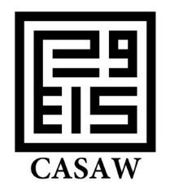

Registration Form
Name (as you would like it to appear on your badge):
University affiliation (if applicable):
Contact details:
Email:
Telephone:

Conference registration (Includes accommodation, all meals and refreshments, and transfer from and to Oran airport)

3 Nights £ 250 (or equivalent in Euro) for waged,
£200 (or equivalent in Euro) for unwaged

4 Nights £ 350 (or equivalent in Euro) for waged,
£ 300 (or equivalent in Euro ) for unwaged
Food preferences (e.g. vegetarian):

Payment:
Please pay by cheque made out to the University of Manchester (CASAW-Mostaganem conference). If you do not have a UK banking account, you may pay in cash on the day of the conference.

Please return this form by 30 June 2015 to the Organizing Chairs:
For EU & US delegates: Manchester CASAW (UK): Professor Zahia Smail Salhi: zahia.smailsalhi@manchester.ac.uk
For MENA delegates: Mostaganem, Algeria: Dr Bakhta Abdelhay: bakhta.abdelhay@gmail.com

