**الــــجــمــهوريــة الــجــزائــريــة الــديــمــقــراطــيــة الــشــعــبــيــة**

**République Algérienne Démocratique et Populaire**

**Ministère de l’Enseignement Supérieur وزارة التــعــليــم الــعالــي و الــبــحــث الــعــلــمــي**



**et de la Recherche Scientifique جــامــعــة عــبــد الــحــمــيــد بن بــاديــس- مــســتــغانــم**

**Université de Mostaganem**

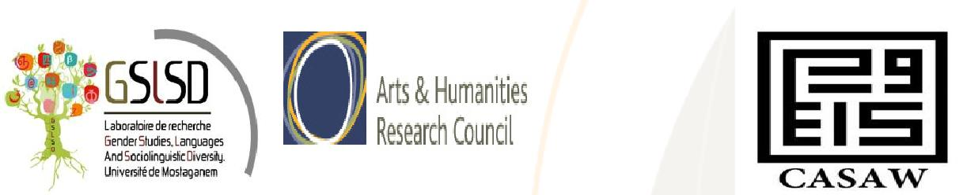

**Mostaganem University and GSLSD Research Unit First International Conference on Women Studies and Sociolinguistics**

**In partnership with the University of Manchester, Centre for Advanced Studies of the Arab World (CASAW)**

**02-04 November 2015**

**Deadline extended**

**15 August**

Women, Empowerment, Citizenship and Development

A rising readiness to empower women over the past three decades has been felt in the measures undertaken around the globe to reinforce social, economic and political gender equity. The Beijing Platform for Action (BPA) in 1995, for instance, accentuated the construction of a gender sensitive education system to “empower & guarantee full and equal participation of women in educational administration and policy and decision making”

(BPA, 1995, Chap. IV, Article 82 ). Along with factors such as race, class, and age comes the concept of gender as a critical sociocultural variable that has been sharpened by an awareness of the substandard status of women.

In recognition of the significance of establishing gender equality, This Conference aims to provide a platform for open dialogue to debate issues relating to gender promotion and women empowerment in the Middle East and North Africa, and to challenge predominant public understandings of Empowerment.

**Organising Chairs:**

Mostaganem, Algeria: Dr Bakhta Abdelhay:  [bakhta.abdelhay@gmail.co](https://outlook.manchester.ac.uk/owa/redir.aspx?C=0lThaftv9EKSCe4ifet92PzBS3xIB9IIEiuEqt1OPutY2NegNfLq97OZuP08EsRbbPimT1luhTQ.&URL=mailto%3abakhta.abdelhay%40gmail.com)m

Dr. Fatima Zohra Benneghrouzi (co-chair): [benfati79@gmail.com](mailto:benfati79@gmail.com)

Manchester CASAW (UK): Professor Zahia Smail Salhi: [zahia.smailsalhi@manchester.ac.u](mailto:zahia.smailsalhi@manchester.ac.u)k

The Organizing Chairs welcome the submission of proposals for research papers and panel that engage with any aspect of **“Women, Empowerment, Citizenship and Development”.**

**A selection of contributions will be considered for an international publication**

We also welcome proposals for workshops, and other interactive presentations, and performances/exhibitions. Non-presenting delegates who wish to attend as conference participants are also welcome.

Please send a 250 words proposal and a 50 words biographical statement to the Organizing Chairs with **"Gender Proposal"** as the subject. The deadline for submission is 30 June 2015. Please include a) name of author(s), b) affiliation, c) email address, d) title of presentation (e) body of proposal. We acknowledge receipt of all proposals submitted.

Papers are welcome in both English and French.

**Topics for individual papers and panels may include but are not limited to:**

* Gender and Language,
* Women and classroom discourse in EFL Contexts,
* Women and forensic linguistics,
* Women’s expression of the self in online communication
* Violence against Women and Women disempowerment,
* The relevance of the Foucauldian notion of power to Women Studies,
* Women’s literature / women in literature,
* Women life writing,
* The Social impact on Women’s testimonies and narratives of resistance
* Women’s narratives as revolutionary
* Women’s Place in History and Women Writing History,
* Women's political participation and the roles of the women MPs and political leaders
* The Sociolinguistic manifestation of Women’s visibility and/invisibility in the struggle for Arab/MENA women’s rights
* MENA women and international networking
* Cultural manifestations as means of resistance (songs, slogans, graffiti, films, photographs etc...)

