Janina Fenigsen’s (very ad hoc) teaching packet for Linguistic Anthropology classes this week.

1. What exactly is the nature of senate hearings? Job interview or trial? The nature of the hearings, per Washington Post article:
https://www.washingtonpost.com/outlook/kavanaughs-senate-hearing-isnt-a-trial-the-standard-isnt-reasonable-doubt/2018/09/20/1eb1ee34-bd15-11e8-b7d2-0773aa1e33da_story.html?noredirect=on&utm_term=.eb2775a75824

2. Who will decide? Who are the people on the Senate Hearing Committee:

a. What can we assume about their position on violence against women? Six members of the committee voted against the reauthorization of the Violence against Women Act:
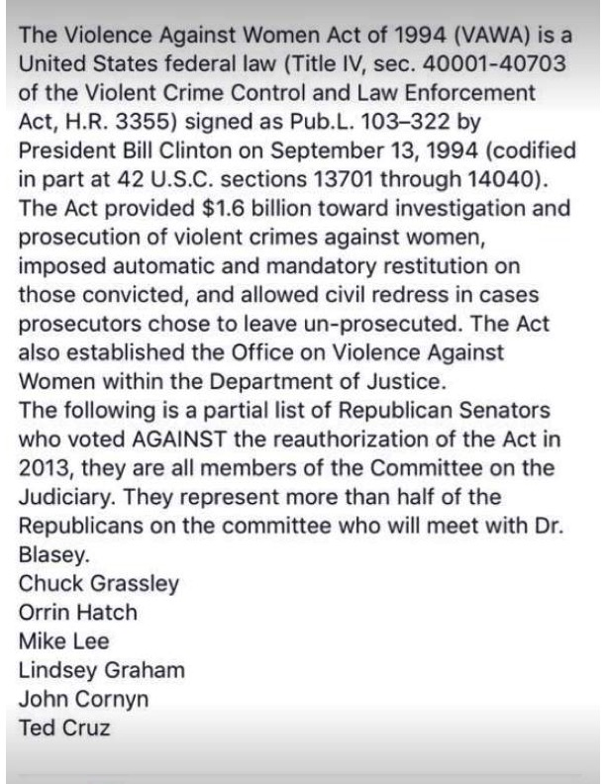

b. Do any of the senators on the hearing committee have a track record of participating in similar events? Three senators to participate in the Ford hearings were in Anita Hill’s hearings.

https://www.cnn.com/2018/09/22/politics/senate-judiciary-committee-chuck-grassley-patrick-leahy-orrin-hatch/index.html

3. The complainant.
Why has Ford not reported the incident to the police or her parents, when it happened? NYT columnist’s perspective, based on his own experience: https://www.facebook.com/CuomoPrimeTime/videos/2265989087017887/UzpfSTY2Nzk4Mjk4MToxMDE1NjE2MzI0MzA5Nzk4Mg/ NYT columnist, Charles Blow

Why Ford may not be able to recall many of the details? Patti (Reagan) Davies experience: https://thehill.com/blogs/blog-briefing-room/news/407851-ronald-reagans-daughter-defends-kavanaugh-accuser-i-was

4. A déjà vu all over again? Politics, Power, and Gender on the Hill. Why many are concerned about the possible bias in the hearings?

Clips from Hill-Thomas 1991 hearings here:
- http://www.youtube.com/watch?v=XfvDcMzyAlY
- http://www.youtube.com/watch?v=egTyaIAaqz8

5. How to move beyond impressions in identifying discrimination and bias in discourse. Mendoza Denton’s “Pregnant Pauses” and CA markers of bullying and bias in Hill-Thomas transcripts.

