Society for Linguistic Anthropology 2020 Undergraduate Essay Contest
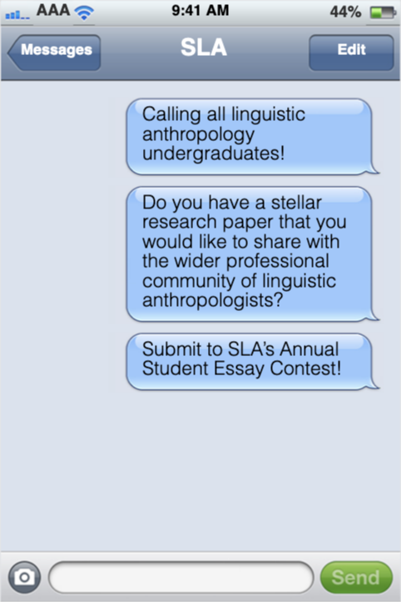
Every year the Society for Linguistic Anthropology (SLA) confers an award for a distinguished undergraduate research paper. The selected winner will be given a cash award, a certificate of accomplishment, and a small travel grant to the AAA Annual Meeting in St. Louis, MO November 18–22, 2020. The winning author, as well as the authors of one or two essays of exceptional quality, will be invited to present their papers on a panel at the AAA Annual Meeting showcasing distinguished student research from both undergraduate and graduate students in linguistic anthropology. Finally, the winning essay will be considered for publication in our signature journal, Journal of Linguistic Anthropology. Essays will be judged on the basis of research contributions to the field of linguistic anthropology, clarity, organization, and engagement with existing scholarship. If this sounds like a paper you have, and it has been written within the last two years, and has not previously been published, then considering submitting your essay to the SLA contest.
Deadline February 15, 2020
Guidelines:
- Submit an original, single-authored paper based on your own research while in an undergraduate degree-granting program.
- Submissions cannot be no more than 2 years old.
- Submissions cannot be previously published or currently under review/submitted for publication elsewhere.
- Students may only win this award and recognition once. Past winners and honorable mentions may not submit revised papers or new papers for consideration.
- Submit one document only.
- Maximum 25 double-spaced pages [inclusive of footnotes and citations]

The first page of your essay should include the following information:
- Title of the paper
- Author’s name; email address; college or university when the paper was written; current university, college, and/or place of employment; and undergraduate degree and date of degree.
- Name of the faculty instructor/advisor for the paper
- The course that the paper was written for (if it was written for a course)
- The date (month/year) that the paper was written

Submit to:
slaundergrad2020@gmail.com

