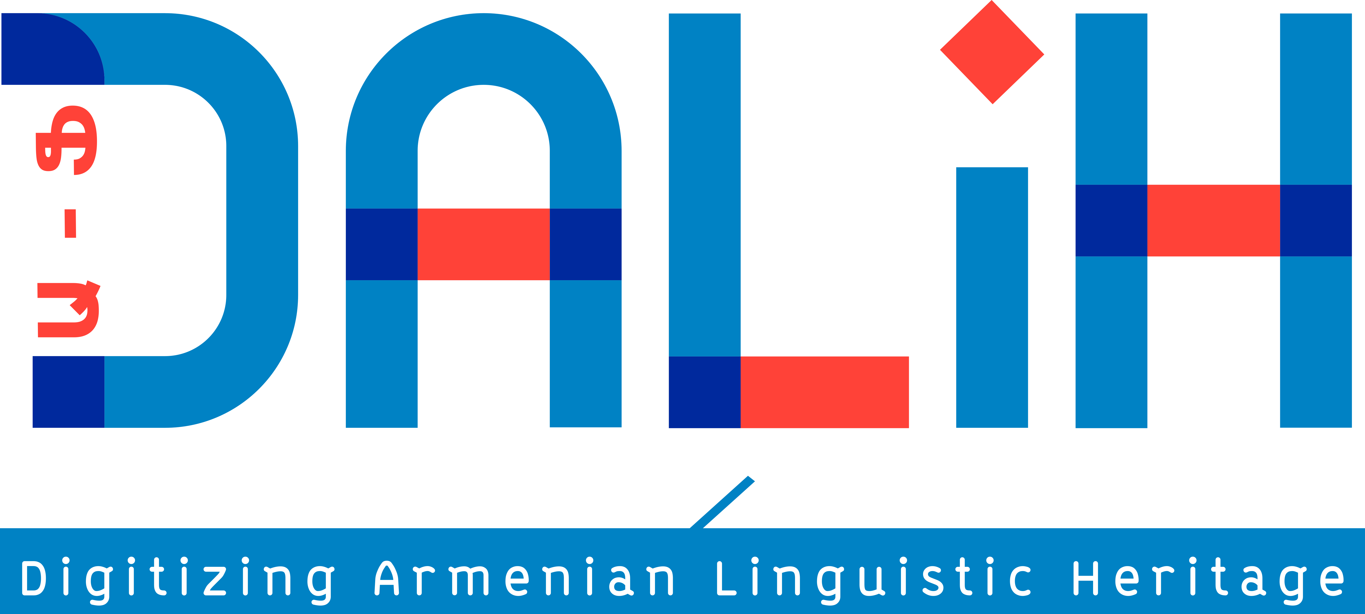
Call for applications
PhD Fellowship in Armenian computational linguistics

INALCO (Institut National des Langues et Civilisations Orientales : www.inalco.fr) invites applications for a 3 year Ph.D fellowship in Armenian linguistics in Natural language processing (NLP) perspective, full-time, 1499 euros/month net, starting in the October 2022 at the linguistic laboratory of SeDyL (Structure et Dynamique des Langues (Unité Mixte de Recherche du CNRS, NALCO and IRD).
The research topic will focus on the morphological or syntactic modeling of the linguistic variation between the Armenian varieties (Classical Armenian, Middle Armenian, Modern Eastern Armenian, Modern Western Armenian, Armenian dialects, as well as the oral discourse of the two modern standards), backed by statistical methods, in the perspective of applying them to automatic corpus annotation and / or automatic detection of varieties in a corpus.
Position details:
Title: Full-time PhD position in Armenian computational linguistics.
Employer: Inalco, 65 rue des Grands Moulins, 75012 Paris
Salary: 1499 EUR net per month
Application deadline: March 15, 2022 (midnight MET).

The applicant will be enrolled in the Doctoral School 265 of INALCO. The PhD thesis will be carried out under the supervision of Anaïd Donabédian. A co-supervisor is possible if necessary. The applicant may be able to teach courses at INALCO.
The applicant will be affiliated to INALCO (Institut National des Langues et Civilisations Orientales: www.inalco.fr), at the linguistic laboratory of SeDyL (Structure et Dynamique des Langues (Unité Mixte de Recherche du CNRS, NALCO and IRD): https://sedyl.cnrs.fr/. Funds will be available for travelling expenses, equipment and experiments.
The position is part of the project Digitizing Armenian Linguistic Heritage (DALiH) Armenian Multivariational Corpus and Data Processing coordinated by Victoria Khurshudyan, and including specialists in Armenian linguistics and in NLP. The project DALiH aims at building for the first time an open-access and open-source unified digital linguistic platform for the whole spectrum of Armenian language variation. Research will be conducted in Natural language processing (NLP) and linguistic perspectives in order to provide full grammatical annotation and Automatic speech recognition (ASR) models for the target Armenian varieties. NLP-based linguistic researches, such as language identification and variety distance measuring, lexical and morphological disambiguation, will be carried out within the framework of the project.

Qualification requirements

The applicants must have a Master degree by October 2022, with a strong academic background in Armenian linguistics, computational linguistics or NLP.
Languages: Having a good command in at least one of the Armenian varieties (Classical, Middle, Eastern, Western); a good proficiency in English and French as a working language is an advantage.
Ability to ability to work independently and in a team, punctuality, attendance.

Application
The application should be sent to victoria.khurshudyan@inalco.fr and the following documents should be attached to your application:
- CV with a full summary of the applicant’s education and experience, references, certificates/diplomas and other documentation that you consider relevant
- a cover letter showing the consistency between the candidate's project and his or her skills, interests and professional projects;
- PhD thesis proposal of 4 to 6 pages in line with the theme of the call, supported by bibliographical references and methodological perspectives, as well as, if applicable, an estimation of additional training needs during the PhD thesis; the project should be as detailed as possible, in order to demonstrate the candidate's ability to project himself into a solid and achievable work program.
- copy of certificates and diplomas, MA transcript, MA thesis and publications;
- the names and contact of two referees for reference letters.

Timelines:

Application deadline: March 15, 2022 (midnight MET).
Preselection: April 15, 2022
Interviews (by videoconference or face-to-face): end of April
Publication of results: May 2022
Registration at the ED and signing of the employment contract between July and September 2022
Recruitment date: October 1, 2022

Contact information :
Application submission: victoria.khurshudyan@inalco.fr.
HR: drh-recrutement@inalco.fr

