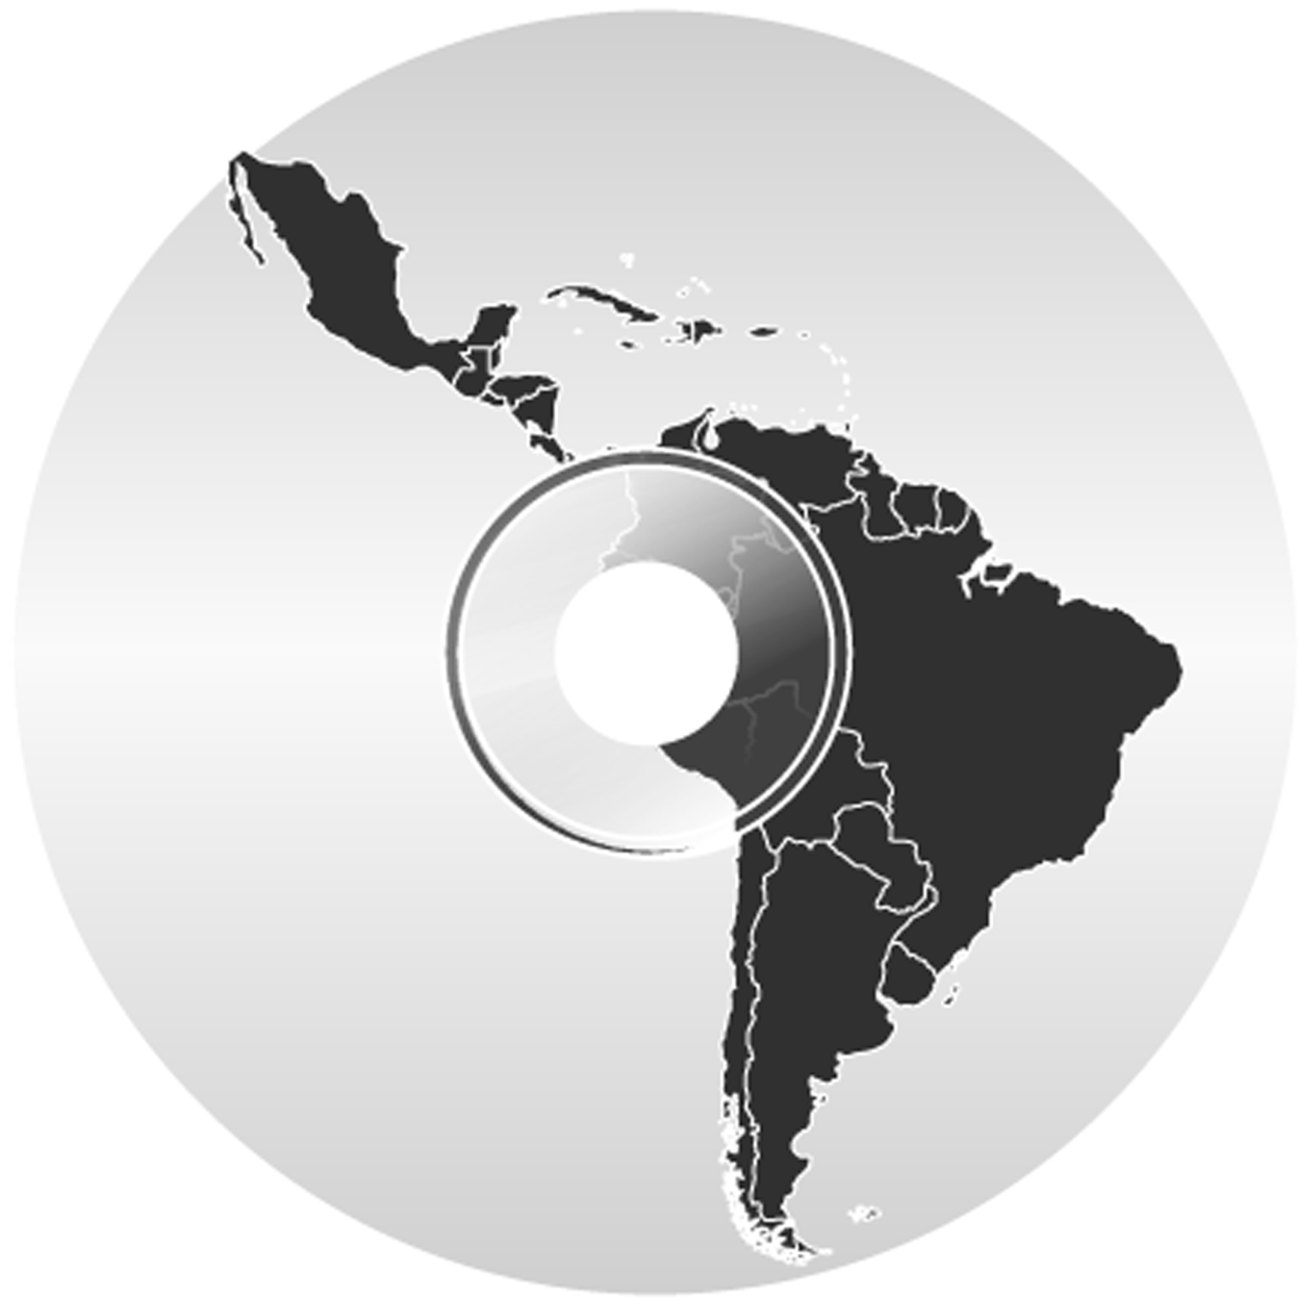
AILLA The Archive of the Indigenous Languages of Latin America
http://www.ailla.org/

I. Overview
AILLA is a digital repository of multimedia resources in and about the indigenous languages of Latin America. Resources in the archive are accessible on the Internet, through parallel interfaces in English and Spanish.

AILLA is a joint project of Anthropology (Joel Sherzer), Linguistics (Anthony Woodbury), and the Digital Library Services Division (Mark McFarland). The project was launched in March, 2000 with seed money from the University of Texas at Austin College of Liberal Arts and is now funded by grants from the National Endowment for the Humaniities and the National Science Foundation.

II. Our mission
Our primary mission is to collect, digitize, and preserve the recorded materials in Latin American languages that have been produced by academics over the past fifty years, and make them available for indigenous language programs and further research.

We also want to foster a network of related archives throughout Latin America, with AILLA serving as a center for technical support and a backup host for the whole network. We would like to see regional and local archives everywhere, with interfaces and services tuned to local communities, but sharing essential metadata and security protocols. AILLA will also help to connect Latin American archive projects with international organizations such as DELAN, IMDI, and OLAC.

III. The collection
The collection centers around recordings (audio and video) of discourse in a wide range of genres, including narratives, chants, conversations, ceremonies, and interviews. Most recordings are accompanied by transcriptions and translations in Spanish, English, or Portuguese. We also want to preserve and disseminate teaching materials for bilingual education and language reclamation programs, and original literary works in indigenous languages, such as poetry, short stories, and essays. The collection presently consists of more than 25 GB of resources in 32 languages from 12 countries.

AILLA's resources come from the international academic community and from members of indigenous communities. Complete information about depositing materials with AILLA, including downloadable metadata forms, is available on our website.

IV. Metadata
AILLA uses a simplified version of the IMDI metadata schema developed at the Max-Planck Institute for Psycholinguistics in Nijmegen. We support the standard mapping from the IMDI schema to OLAC metadata elements.

The crucial concept in the IMDI schema is the session bundle: resources are composed of a set of related files, such as a recording in several formats accompanied by textual annotations, illustrations, etc. AILLA's metadata consists of the following:
- Information about the depositor: contact info, project name, sponsor, etc.
- Information about the principal participants in the creation of the resource:
  - name, affiliation, & contact information
  - role: {annotator, author, collator, consultant, contributor, creator, depositor, editor, filmer, illustrator, interlocutor, interpreter, interviewer, performer, photographer, publisher, recorder, researcher, responder, speaker, transcriber, translator}
  - family/social role & sex
- Genre of the central piece in the resource (e.g., the recording of a narrative): {article, ceremony, chant, commentary, conversation, correspondence, dataset, debate, description, drama, essay, exam, grammar, greeting/leave-taking, guide, history, instructions, interview, language_play, lexicon, meeting, myth, narrative, oratory, poetry, prayer, problem set, procedure, proverb, reader, recipe, sketch, song, textbook, unintelligible_speech, wordlist, workbook}
- Language & language code.
- Information about the resource's provenance: date & place of recording, original medium
- References to related materials, in the archive or in print.
- Information about the files in the resource: access level & related info, size in bytes, length in minutes, number of pages, digitization specs, etc.

V. Security
Users can freely browse the metadata for AILLA's resources, but in order to access any file they must register, agree to the Terms and Conditions, and log in. Depositors can further protect sensitive materials by means of the graded access system, which provides four levels of access:
- Free public access.
- Automatic control. Three automatic protocols:
  - Passwords offer fine or coarse control. For example, a secret word disseminated individually finely distinguishes authorized users. For coarse control, a password such as the word for 'friend' in an indigenous language, which only speakers and a few researchers would be likely to know, would let in all appropriate users, with little risk of an inappropriate user gaining access.
  - Time limits would typically be the lifetime of a speaker, or some generally agreed upon limit for a researcher's exclusive use of data (e.g., 3 years).
  - Conditions that the user must agree to, such as always crediting speakers by name, can be specified by depositors This control would not prevent a dishonest person from accessing a resource, but would provide electronic evidence that the user had agreed to the conditions, should a dispute arise.
- Depositor control. Users contact the depositor directly to ask for permission to access the resource. The depositor contacts AILLA, and archive staff adjust the user's access list. This allows depositors to know who is interested in using their materials. Most depositors will be reachable by email, so that the communication cycle can be automatically facilitated by archive software.
- Indigenous control. Users contact AILLA and we request permission on their behalf from the indigenous person or group that controls the resource. This allows indigenous people to know who is interested in their materials. Note that this cycle could take months, since communication with the indigenous community would most likely take place by surface mail.

VI. Contact us
Web site: http://www.ailla.org
Email: ailla@ailla.org
Snail Mail: AILLA c/o Joel Sherzer
Dept. of Anthropology, EPS 1.130
1 University Station C3200
The University of Texas at Austin
Austin, Texas 78712-1086
U.S.A.

Phone: (512) 495-4604

