Franco-Japanese Symposium

*Program*

**Sound data analysis  
and reference corpora**

– **Sharing Experiences** –

Paris, 2013, November 18 – 20

LLL (Loire Linguistics Lab – UMR 7270)

University of Orléans – University of Tours – BnF – CNRS

&

NINJAL (National Institute for Japanese Language and Linguistics)

**Macintosh HD:Users:gaby:Desktop:NINJAL DGLF:logo_ninjal.pdf **

NINJAL LLL

<http://www.ninjal.ac.jp/english/> <http://www.lll.cnrs.fr/>

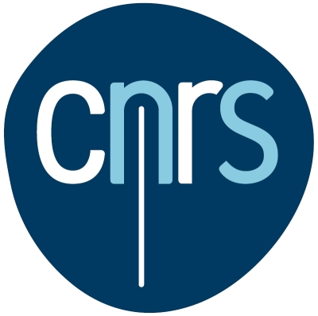 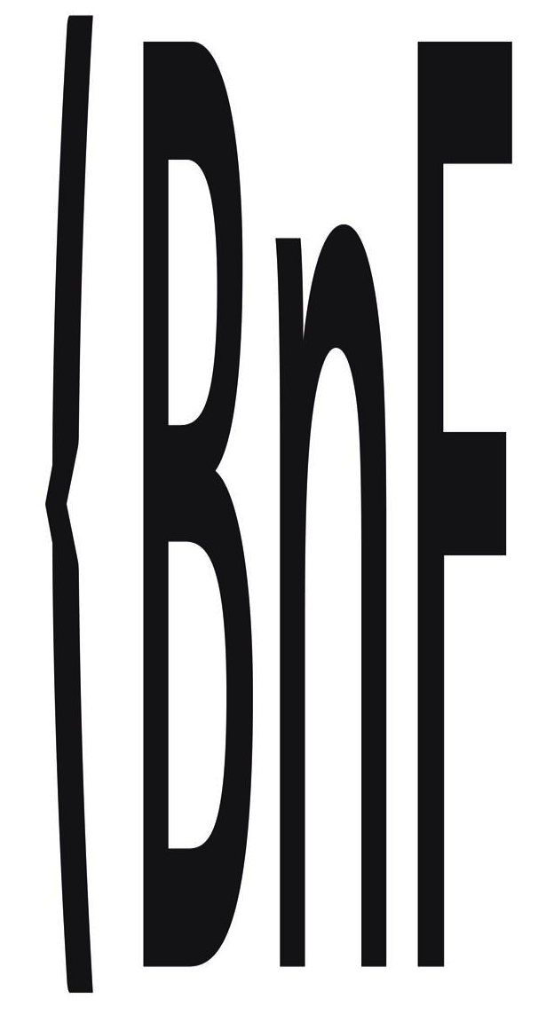

The aim of this symposium is to compare practices and reflections on processing and analysis of speech recordings.

Together for three days linguists, didacticians and curators will share their knowledge and expertise in the treatment of sound data.

The collection, storage, transcription, scientific use, educational applications and public dissemination will be discussed as described in the program.

*In partnership with*

Bibliothèque nationale de France (French National Library)

*Special support by*

DGLFLF (Délégation Générale à la Langue Française et aux Langues de France)

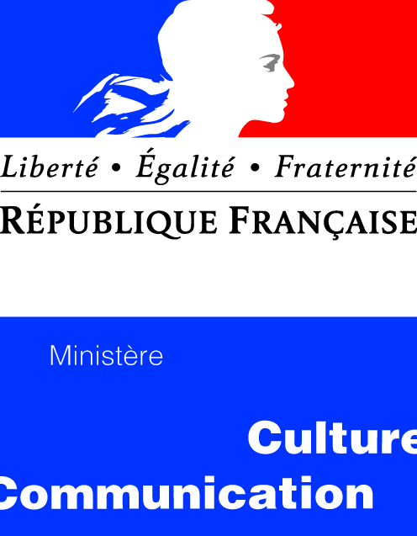

IRCOM consortium (HUMA-NUM)



&

MCJP (Maison de la culture du Japon à Paris)

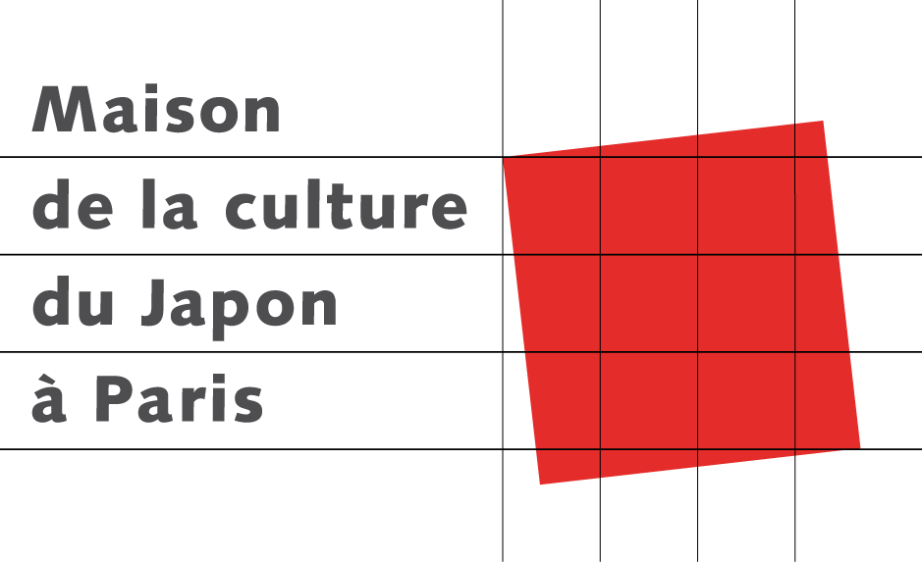

*The didactic session is supported by*

la Société Japonaise de Didactique du Français

**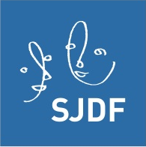**

&

l’Association des Enseignants de Japonais en France (AEJF)

****

***Steering committee***

Olivier Baude (University of Orléans / LLL / Huma-Num)

Jean Bazantay (University of Orléans / AEJF)

Gabriel Bergounioux (University of Orléans / LLL)

Pascal Cordereix (BnF / LLL)

Christophe Gauthier (BnF / LLL)

Annette Gerstenberg (University of Berlin / Institute of Roman Philology)

Layal Kanaan-Caillol (Ortolang / LLL)

Kikuo Maekawa (NINJAL)

Agata Savary (University of Tours / LI)

Marie Skrovec (University of Orléans / LLL)

Yumi Takagaki (Osaka Prefecture University / SJDF)

**Monday, November 18**

(*Location*: French Ministry of Culture 182 rue Saint-Honoré, 75001, salon Malraux)

The institutional context of research on sound corpora in France

09:00 Welcoming participants

09:30 Introduction

Address by Xavier North

Director of the Delegation for French Language and Languages ​​of France (DGLFLF) - Ministry of Culture

9:45 ILF (French Linguistics Institute)

Franck Neveu (Université de la Sorbonne – STIH, Paris IV), Director of ILF

“Compiling the reference corpus for French Language”

10:15 HUMA-NUM (Humanités Numériques / Digital Humanities)

Olivier Baude (LLL – Chairman of the Scientific Council HUMA-NUM)

“Language Resources and Digital Humanities”

10:45 *Break*

11:15 IRCOM (Consortium for Oral and Multimodal Corpora)

Gabriel Bergounioux (LLL – Executive Committee IRCOM)

“A shared experience in oral corpora”

11:30 ORTOLANG (Open Resources and Tools for Language)

Jean-Marie Pierrel (ATILF, University of Lorraine – Director of ORTOLANG)

“What is ORTOLANG?”

12:00 *Lunch*

NINJAL : The reference corpus in Japan & LLL

02:30 NINJAL

Kikuo Maekawa (NINJAL – Tokyo)

“The National Institute for Japanese Language and Linguistics”

04:00 *Break*

04:30 LLL

Gabriel Bergounioux (Orléans), Jean-Michel Fournier (Tours) & Layal Kanaan-Caillol (Orléans) – LLL

“LLL oral corpora and orally expressed corpus”

05:30 Conclusion: Corpora documented Research (shared experience)

06:00 *End*

**Tuesday, November 19**

(*Location*: Maison de la culture du Japon à Paris, 101 bis Quai Branly, 75015)

Compiling corpora in Europe: IDS, BNC, IPI PAN   
  
  
09:00 Introduction by Sawako Takeuchi (House of Japanese culture in Paris)

09:30 Corpus from IDS (Institut für Deutsche Sprache)

Arnulf Deppermann & Thomas Schmidt (Mannheim)

“Reference corpus for German Language”

10:15 *Break*

10:45 Corpus from BNC (British National Corpus)

John Coleman (Oxford)

“Reference corpus for English Language”

11:30 Corpus from IPI PAN (Polish National Corpus)

Agnieszka Mykowiecka (Varsovie)

“Reference Corpus for Polish Language”

12:15 Synthesis of the discussions

12:30 *Lunch*

Corpus-assisted language learning

02:00 Introduction

Nozomi Takahasi (AEJF / Association of Japanese Teachers in France)

Setsuko Shinozaki (MCJP/ Advisor for Japanese language teaching)

I

Inaugural communication

02:15 Jae-Ho Lee (University of Tsukuba)

“What learner corpora say: comparing oral and written corpora”

03h15 *Break*

II

Experiences presentations

03:30 Jean Bazantay (University of Orléans/AEJF)

“Japanese textbooks through the prism of corpora: the case of ‘mono da’”

03:50 Sumikazu Nishio & Yayoï Nakamura (INaLCO, Paris)

“Presentation of the corpus of texts learners of INaLCO”

04:10 Debate: “Experience exchange”

Moderated by Akiko Nakajima (CRCAO, University of Paris 7)

04:30 *Break*

III

FFL in Japan

04:45 Yumi Takagaki (Osaka Prefecture University / SJDF)

“FFL and applications of corpus studies in Japan”

05:15 Takeki Kamiyama (LPP, ILPGA, Université de Paris 3)

“Phonetics-phonology in French as L2 and oral corpora”

05:45 Summary of discussion (Tomoko Higashi, University of Grenoble 3)

06:00 *End*

**Wednesday, November 20**

(*Location* : Bibliothèque nationale de France, Quai François Mauriac, 75013)

National Library: Assignments in sound archives

09:00 Introduction

Bruno Racine (or his representative), President of the BnF

09:30 Pascal Cordereix (Department of Audiovisual – BnF/LLL)

“Collect and archive: from an example of filing and processing (ESLO)”

10:30 *Break*

11:00 Christophe Gauthier(Department of Audiovisual – BnF/LLL), Isabelle Nyffenegger (Department of Audiovisual – BnF) & Mireille Ballit (Department of Audiovisual – BnF)

“The Audiovisual Departement and Gallica: How to provide a public access to data”

12:00 *Lunch*

European perspectives

02:30 Introduction by Yoshiyasu Tanaka,

Cultural Counsellor (Embassy of Japan)

02:45 Sophie David *&* Jean-Luc Minel (MoDyCo – University of Paris Ouest)

“European Infrastructures: DARIAH and CLARIN”

04:00 Visit of the BnF collections

Laboratory instruments, phonographs and recording systems of XIXth and XXth centuries (Charles Cros Museum)

05:00 *“Verre de l’amitié”*