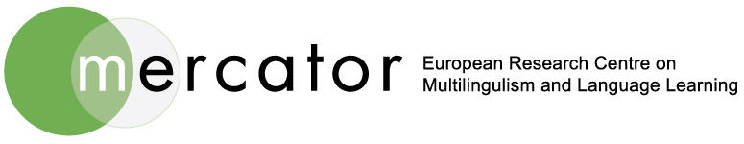

Re-visiting the pedagogy of the languages of minority communities

Date: Friday 26th June, 2015

Venue: VG01, Vernon Square Campus, SOAS, University of London, Penton Rise
London, WC1X 9EW (closest stations – Kings Cross/St Pancras International)

Organisers: Institute of World languages @ SOAS (Univ of London) & Mercator (Fryske Akademy)

This seminar continues the established collaboration between SOAS & Mercator, European Research Centre for Multilingualism & Language Learning (Fryske Akademy). This time the focus is on pedagogical aspects and includes policy issues as well as practices involving resources ranging from story-telling to Open Educational Resources (see below for further details). It is anticipated that both researcher and practitioner based perspectives will be represented.

Registration deadline: 22nd June, 2015. £5.00 payable in cash only on the day please; advise if you have special dietary requirements. YOU WILL NEED A CONFIRMATION EMAIL FROM US TO ATTEND as there is limited space; please register as soon as possible to avoid disappointment by emailing: mercator@fryske-akademy.nl

Programme

09.30: Registration & Coffee
10.15: Cor van der Meer, Mercator (Fryske Akademy), & Itesh Sachdev, SOAS (University of London): Welcome & Introduction
10.30: Sarah Cartwright, Our Languages Project, London: Understanding the languages landscape
11.15: Fatima Khaled, Peace School, London: Motivating teenagers in the digital age
12.00: Manjula Datta, London Metropolitan University: Language development through storytelling
12.45: Lunch
1.45: Marit Bijlsma, Mercator (Fryske Akademy): Open Educational Resources in multilingual European contexts
2.30: Wim de Boer, Afûk Institute for the Frisian Language: Frisian MOOC
3.15: Coffee
3.45: Anne Pauwels, SOAS (University of London): Advantages/disadvantages of current practices with panel/audience in discussion
4.30: Julia Sallabank, SOAS (University of London): Language pedagogy for endangered languages
5.15: Closure

