From Murray Garde:

One of my favourites is the Bininj Kunwok word burrmarlarla which is a rare song word used in a morrdjdjanjno series hunting song about antilopine kangaroos. It is the name for a male antilopine kangaroo that is resting, lying on its side in part shade during the heat of the day and the movement of the dappled light on its fur gives it the appearance of having covered itself with white clay, just as hunters do when they hunt these large animals.

Another is -marnedurnkarrme (marne ‘benefactive' durn ‘depression’ karrme ‘have/hold’). This refers to any birth mark on a person’s body such as a patch of different pigmentation or a slight depression. Such marks are thought to be the result of the father spearing an animal, typically a kangaroo, near a site where the child’s conception spirit was residing before a person’s conception and birth. The mark on the child’s body is an analogue of the place where the father’s spear entered the body of the animal thus facilitating the entry of the conception spirit into the mother’s body. The word with a first person singular pronominal prefix ngamarnedurnkarrme would mean ‘I carry this body mark which represents the wound on the animal my father killed by spearing it, thus facilitating the entry of my conception spirit into my mother.'

From Barry Alpher:

Australian example: Yir-Yoront tharr (past thurr), in its widest sense 'to put, to leave something (in a place)', is very polysemous (senses, not always clearly discrete, numbered 1-17 in Yir-Yoront Lexicon). It can mean 'create (as the Ancestors did) or institute (a thing or practice like a ceremony)' (9), as in Woy-Pinpan oylt thurr pul 'they instituted the Pinpan ceremony there', or 'leave off making or doing, relinquish (as a practice)' (5), as in Werr-werr, karw tharrl ngeyn; yorrarr wellolonl 'bough-sheds, we don't stop (making) them, (we) still build them'.

But my all-time favorite is German reizen, which can mean 'provoke or irritate (as a skin rash might)' or 'appeal to, attract, arouse, charm, intoxicate (as something or someone beautiful might)'. Others have made this same observation about reizen.

I think German in general is a fertile field for these things. Consider Auswurf, lit. 'out-throw', which can mean 'cream of the crop' or 'rubbish'.

From Bill Forshaw:

At the risk of Murrinhpatha overload here is my favourite example of recent months.

It is the word tek.

When used with the noun classifier for animals ku this refers to the 'red-tailed black cockatoo' (Calyptorhynchus Banksii). "It has a loud distinctive call and its language names are based on this sound" (Nambatu et al 2009:87).

When tek is used with the residual noun classifier nanthi it refers to the plant 'red root' (Haemodorum Coccineum). "The large red coloured root is dug up during the late wet or early dry season and chipped into small pieces. The chips are then placed in boiling water with fibre to colour the fibre" Nambatu et al (2009:48).

The link between these two uses is the distinctive colouring of both the bird's tail and the plant's root and potentially the plant's flowers.

Nambatu, N. J., Nudjulu, P. P., Narna, L. J., Munar, K. J., Kungul, D. A., Munar, L. R., … Wightman, G. (2009). Marri Ngarr and Magati Ke plants and animals: Aboriginal knowledge of flaura and fauna from the Moyle river and Rak Neninh areas, north Australia (Vol. 32). Batchelor: Batchelor Press.

From Mark Clendon:

One of my favourite Worrorra words is the root =warnkarra 'adult offspring' because English has no equivalent, so we have English speakers referring to 'my kids' when the kids in question are in their 40s or older -- a silly lexical gap. Among derived forms are iwarnkarra 'adult son of some parent,' nyimbarnkarranya 'adult daughter of some parent' and arrwaawarnkarreya 'adult offspring of some parent(s).'

Also the preverbal infinitive ngawurriy 'drink the cooked blood and juices in the body-cavity of a roasted kangaroo' (a delicacy).

From Åshild Naess:

I like Norwegian ‘hangle’ ([hɑŋɽə] in my southeastern dialect) (intransitive verb). It means something like ‘to be a bit unwell but not really properly ill over a period of time, neither getting better nor worse’. The extendedness in time is an intrinsic part of the semantics; you couldn’t hangle for a day or a few hours, that would just be feeling poorly. I’d say at least a few days for hangle to apply.

From Maia Ponsonnet:

I think my favorite word is the Dalabon v.i. njirrk(mu), wich can mean 'be remorseful or resentful, feel upset, brood over...', as well as 'be confused, not know, hesitate...'. I cannot help finding that the form is perfectly sound-symbolic (there is absolutely no ground for this, it's just my feeling).

I've actually published on the semantics of njirrk(mu) (attached) but the article is in French.

From Alex Francois:

Let me propose a couple random words from the language Mwotlap (Oceanic, northern Vanuatu):

bemyowyow [ᵐbɛmjɔwjɔw] (n.)
(lit. "jumping butterflies") the tiny sparks that can be seen flying above a fire.

gal [ɣal] (v.t.)
(1) mislead [s.o.], lie to [s.o.], deceive, by saying words that are untrue.
(2) comfort [a crying child] by telling them a story or singing them a song.
(3) blow into o.'s hands onto magic tree leaves to rouse [a magic power].

halvan [halvan] (n.)
(1) an object that has reached the island shores by floating (hal), like a coconut or a debris.
(2) a foreigner (e.g. a linguist).

I've published a little bit on polysemy in northern Vanuatu languages:
- François, Alexandre. 2013. Shadows of bygone lives: The histories of spiritual words in northern Vanuatu. In Robert Mailhammer (ed.). Lexical and structural etymology: Beyond word histories. Studies in Language Change, 11. Berlin: DeGruyter Mouton. Pp.185-244. [other link on Academia]
see e.g. p.198 the polysemy of *totoɣale [V] (lit.‘chop falsely’) ‘notch (wood)’ → ‘carve an eﬃgy’ → [N] ‘eﬃgy, image, picture; (mod.) photograph’

or p.214, the rich polysemy of *[a]tamate (or of na-tmat in modern Mwotlap):

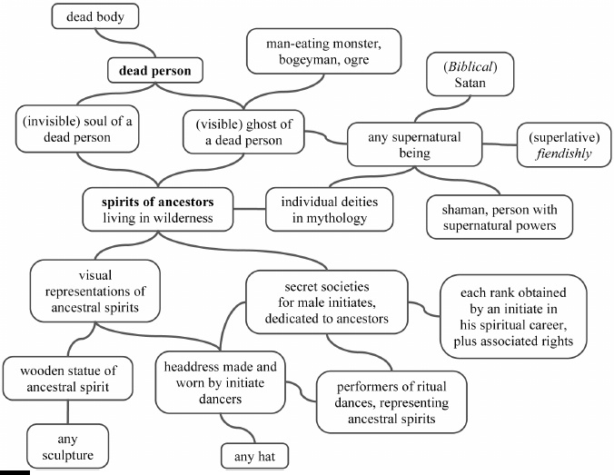

From David Valls:

For example, in Catalan we have three different words to define a hole: "forat", "sot" or "clot". A "forat" is a hole in which you can see the other end. A "sot" is a hole with no ending, it's just a small deep "scratch" in the surface, like the ones you find in the roads. A "clot" is the same than a "sot" but a little deeper. In Spanish there's only one word that defines hole: "agujero".

In Catalan we have two different ways of drying. Things that normally contain water such as rivers or pounds, we say that we can "assecar" them (dry). But, when we dry our hands, face, cloths, etc., let's say things that normally do not contain water we say "eixugar". In Spanish they make no difference, they always use "secar" (dry).

In Catalan we have a very and unique word formation case which some say that's only found in some Australian languages, but it's unique in European languages. I'm not sure if this statement is true, though. The word formation goes with a body part and a verb to create another word, most of the times the resulting word has not relation at all with the meaning of the two words that created it. There are many of these words, but some are: corglaçar (lit. heart-freeze) to frighten; ullprendre (lit. eye-take) to delight; sangtraït (lit. blood-betrayed) bruise; capficar (lit. head-put in) to worry; capgirar (lit. head-turn) to turn over a situation, an object, and many more.

Some other things... in Catalan we say "cap per avall" (lit. head down) for upside down, while in Spanish is "boca abajo" (Lit. mouth down), so for some is the head and for others is the mouth. "Avall" (down) means "to valley", so it's a grammaticalization of the word valley. To say up we say "amunt" (to mount).

And one last curiosity: in many languages, like in English the verb "to go" it is used to express future. E.g. I'm going to the movies. The same goes for Spanish, Portuguese, French, etc. But in Catalan there are certain constructions where the verb to go is used to express past. E.g. "Jo vaig menjar una poma" means I ate an apple. Jo (I) vaig (present tense verb to go used as an auxiliary) menjar (infinitive verb to eat) una (one) poma (apple).

From Robert Hoogenraad:

Hi Rachel,
I’ve got heaps, for Warlpiri and other Central Australian languages, Dutch/English, and Iban/Malay/Bahasa Indonesia. I’ll try to put together what I have into a short paper for you.

They range over a number of types, but Australian languages they include particularly what Ken Hale called “actual/potential”. Here is an example (a short story really):

I was driving along a bush track out of Yuendumu, with Harry Jakamarra Nelson. It’s particularly striking because Harry’s English is quite superb. We saw two men walking through the bush, looking at trees, obviously looking for something. I said to Harry: “What are they doing?” He replied (in English) “They are looking for a boomerang”. I did a double take when I suddenly realised what he meant: they are looking for the shape of (the potential) of a boomerang. Despite his good English, his reply was semantically Warlpiri, where the word karli (boomerang) covers both actual and potential. Of course, it doesn’t in English.

From Linda Barwick:

Italian - magari - "perhaps" and "if only it were so but alas..."

From Louise Baird:

On reading your request the immediate words that popped into my head were a couple created by the ke- -an circumfix in Indonesian, that creates an abstract noun roughly meaning 'to be overcome by the root'. So kehujanan (root hujan 'rain') means 'to be overwhelmed by rain' or 'soaked to the skin', and kepedisan (from pedis 'spicy hot') which means 'to be overcome by spice' (to have a burning mouth, unable to talk, possibly trouble breathing).

From Simon Devylder:

Paamese (Vanuatu) has the word tissa which can refer to the place of a village reserved to burn wastes. It is also found in longi tissa 'I feel sad', and in avu tissa which means...'mother-in-law' !

There are strict rules of avoidance in Paamese kinship relations, and the concept tissa refers to, seems to be highly complex, therefore I would be careful not to jump to the conclusion that 'garbage', 'sadness' and 'mother-in-law' are the same thing, although that would be kind of funny, and they are definitely connected. To my understanding tissa refers to something tabu and forbidden but which should be treated with high respect at the same time. The semantic connections are certainly not obvious and would require further investigations.

I am currently investigating the concept behind this word, so apologies for the very incomplete answer, but I thought it was worth mentioning it since it is definitely an interesting concept with no equivalent in the (few) languages I know.

From Rosey Billington:

Some examples from Lopit (South Sudan)

- The name for a particularly dangerous and aggressive rattlesnake is itibiromotio [ɪ́tɪ́bɔ̀rɔ̀mòtjô] - which means 'it will cause you to smash your pot' (because you will get frightened, and the pot of water will fall off your head while you are carrying it)

- The word for the month of December is Isaramanyihari [ɪ́sáɾàmáɲìxáɾɪ́] - which means 'give some water to your uncle/male elder' (and is fairly apt for December in South Sudan).

