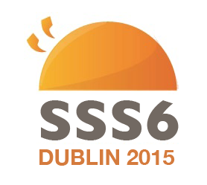

You are warmly invited to participate in the 6th Sociolinguistics Summer School which will be taking place in Trinity College Dublin from 4th to 7th of August 2015. On behalf of the 6th Sociolinguistics Summer School Committee, we would like to encourage linguistics students to attend and participate in this year’s Summer School (early bird registration fee 55 euro). While we normally encourage postgraduate students to participate, we acknowledge the contribution made by undergraduate students, particularly as regards to poster presentations.

This year’s Sociolinguistics Summer School will have four distinguished linguists as plenary speakers: Prof. Li Wei, Dr. Jeffrey Kallen, Dr. Bettina Migge and Dr. Eleanor Lawson. The conference will cover a variety of topics, including: code-switching, corpus linguistics, language and migration, and sociophonetics. We welcome students from any institutions who wish to present on these topics, however, we also encourage students to present on other topics related to Sociolinguistics.

For more details please visit our website: https://www.tcd.ie/slscs/news-events/SSS6/
and our blog: https://sss6dublin.wordpress.com/

We look forward to hearing from you!

Yours sincerely,
SSS6 Organising Committee

