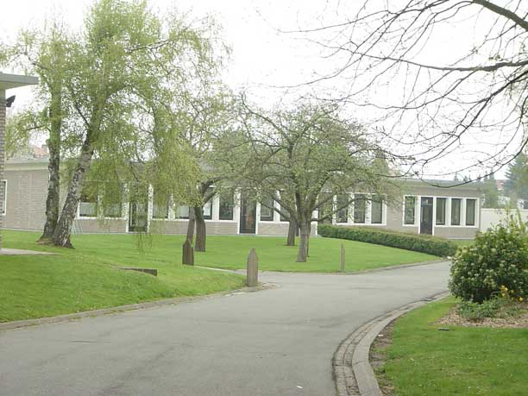
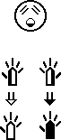



European Sign Writers Organisation
1st Seminar

Thursday 21st July 2005

09.00 Registration – Tea & Coffee

09.30: Introduction – Shane O hEorpa & Kathleen Heylen

10.00: Talk on Education & SignWriting Techniques
- Stefan Wöhrmann & Kathleen Heylen

11.00: General Discussion – led by Ingvild Roald

12.00: Lunch

13.00: informal discussion/practice – two groups

1) Spelling Workshop – led by Stefan Wöhrmann and Sara Geudens
2) Technology/Computer Workshop – led by Trevor Jenkins

14.30: Coffee and Tea Break

15.00: Continuation of Workshops

16.30: Break for the day

20.00: Independence Party in Town – coordinated by Kathleen Heylen

European Sign Writers Organisation
1st Seminar

Friday 22nd July 2005

10.00: Welcome by Shane O hEorpa & Kathleen Heylen

10.05: Daniel Noelpp – Talk on ‘Tiger’ – a SignWriting program

10.50: Break

11.10: Lars Majewski – Talk on ‘Python’ – a SignWriting program

12.00: Lunch & ESWO discussion

13.00: Informal discussion/practice – two groups

1) Spelling Workshop – led by Stefan Wöhrmann and Sara Geudens
2) Technology/Computer Workshop – led by Trevor Jenkins

14.30: Coffee and Tea Break

15.00: Closing Discussion – vote on the 2nd ESWO Seminar 2006

16.30: End of the Seminar

