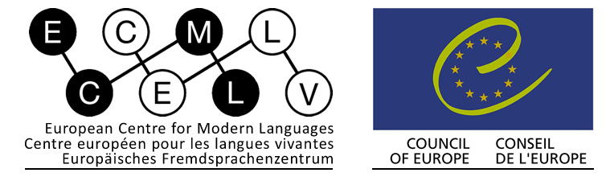

C O N F E R E N C E
A N N O U N C E M E N T

The Pro-Sign project, funded by the European Centre for Modern Languages (ECML), is a first and highly significant step toward the establishment of European standards for specifying proficiency levels for use in Deaf Studies and Interpreting programmes offered at tertiary level.
Part of this Pro-Sign project is the organisation of a workshop “Signed Languages for Professional Purposes” for invited representatives of ECML member states on 15-17th April 2013, in Graz, Austria.

In order to prepare for this workshop, the Pro-Sign Expert Team is organising a conference open to all professionals and researchers interested in developing and establishing common sign language levels.

The CEFR for Signed Languages
in Higher Education

Dates Saturday 13th and Sunday 14th April 2013
Venue To be announced, in Graz, Austria
Organisers Lorraine Leeson, Ireland; Tobias Haug, Switzerland;
Christian Rathmann, Germany; Beppie van den Bogaerde, The Netherlands
Working languages English and International Sign
Conference Fee € 200.-
Registration http://prosign-estw.eventbrite.ie/#
Contact mail: conference-office@cefr4sl.eu

Preliminary program
Pre-Workshop Conference
CEFR for Signed Languages in Higher Education in Europe
Time | Saturday, 13.04.2013 |  |  | Time | Sunday, 14.04.2013
09.30-10.00 | Welcome/general information |  |  | 09.00-9.15 | General information
10.00-10.30 | key note/general presentation re CEFR4SL |  |  | 9.15-10.30 | Reports from WS 1-4 & Discussion
10.30-11.00 | Coffee break |  |  | 10.30-11.00 | Coffee break
11.00-12.30 | Workshop 1: CEFR-aligned curriculum &  implementation of CEFR  Language(s): IS & E | Workshop 2:  Assessment issues  Language(s): IS & E | Workshop 3:  "Ambassador workshop”  Language(s): IS | 11.00-12.00 | Continuation of Reports from WS 1-4 & Discussion
12.30-14.00 | Lunch |  |  | 12.00-13.30 | Lunch
14.00-15.30 | Repetition WS 1  Language(s): IS & E | Repetition WS 2  Language(s): IS & E | Workshop 4: how teams work together to change the curriculum | 13.30-15.30 | Decisions and next steps
15.30-16.00 | Coffee break |  |  | 15.30-16.00 | Coffee break
16.00-16.30 | Summary of the day, short reports from workshops |  |  | 16.00-17.00 | Closing
19.00-20.00 | Reception in the City Hall
IS International Sign E English

http://www.ecml.at/F5/tabid/867/language/en-GB/Default.aspx

